**Client-Server Application**

IT351-1902B-01

Jay C. Davé

June 19, 2019

Individual Project 5

Unit 1 3

Client-Server Applications 3

Psuedocode 3

Unit 2 5

Class Diagram 5

Sequence Diagram 6

Multi-threaded Server Applications 6

Screenshots 6

Unit 3 8

Database-Driven Desktop Application 8

Screenshots 8

Delete 8

Create 8

Update 9

Read 9

Unit 4 10

Database-Driven Web Applications 10

System Architecture 10

Diagrams 10

Future Development Plan 11

Q&A 11

Unit 5 14

Test Plan(s) 14

Customer Testing 14

Display Customer Table 14

Create A New Customer 17

Update Customer 20

Delete Customer 23

Product Testing 25

Display Product Table 25

Create Product 27

Update Product 30

Delete Product 31

User Manual Requirements 35

Setup 35

SQL Script(s) 36

Create User & Grant Permissions 36

Create Database 36

Create Customer Table 36

Create Product Table 36

Seed Customer Table 36

Seed Product Table 36

CRUD Functionality 38

# Unit 1

## Client-Server Applications

### Psuedocode

Class Backend

Set InputStream Input

Set Int Port

Function Main

Create Socket connection

Iterate over Socket object to keep connection open

Call WriteDataToFile

End Function

Function ConvertInputStreamToString

Accepts InputStreamReader as parameter

Converts the InputStream and return String

End Function

Function WriteDataToFile

Accepts String client_response and String filename as parameters

Will write to correct file based off of filename paremeter.

End Function

End Class

Class ServerCommunicationHelper

Set Dictionary of type String, String

Constructor

Set String getField

Function UnpackageFields

Iterate over dictionary

Pull out the respected values based on ClientCommunicationHelper builder

End Function

End Class

Class Frontend

Function getSocketPrintWriter

Accepts two parameters of type String and Boolean

Create socket connection

ReadFile based on String that is passed in

End Function

Function ReadFile

Accepts one parameter of destination of type String

Will look for to read the file based off the destination string.

End Function

End Class

Class ClientCommunicationHelper

Set Dictionary of type String, String

Constructor

Function addField

Accepts two parameters of type String and string

End Function

Function PackageFields

Iterate over dictionary and build response body

End Function

End Class

# Unit 2

## Class Diagram

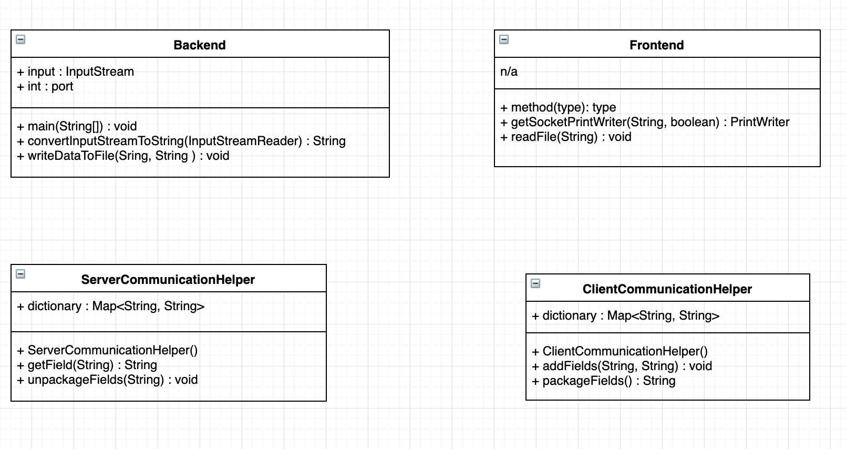

## Sequence Diagram

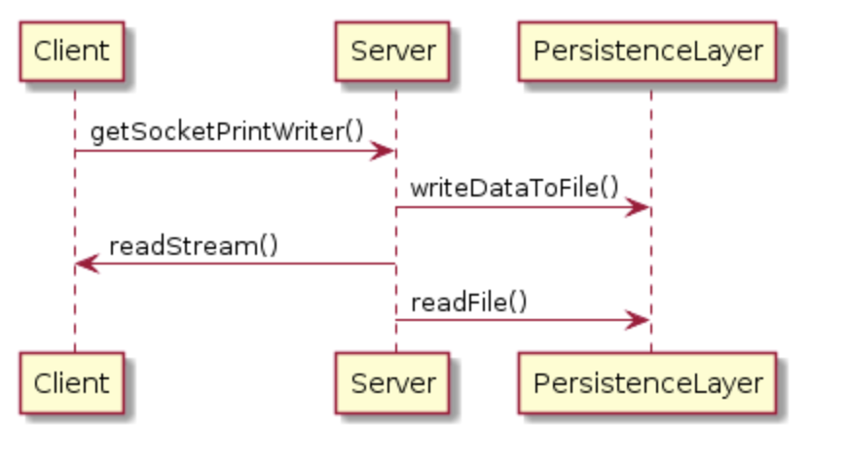

# Multi-threaded Server Applications

## Screenshots

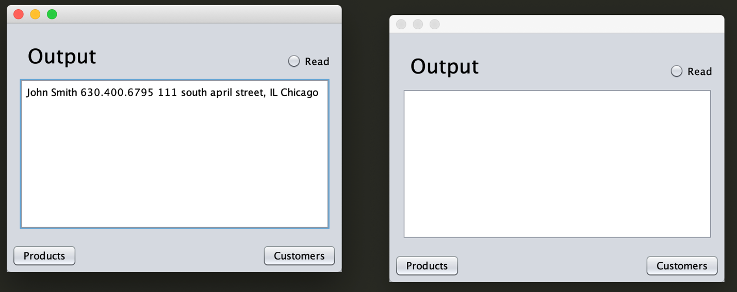

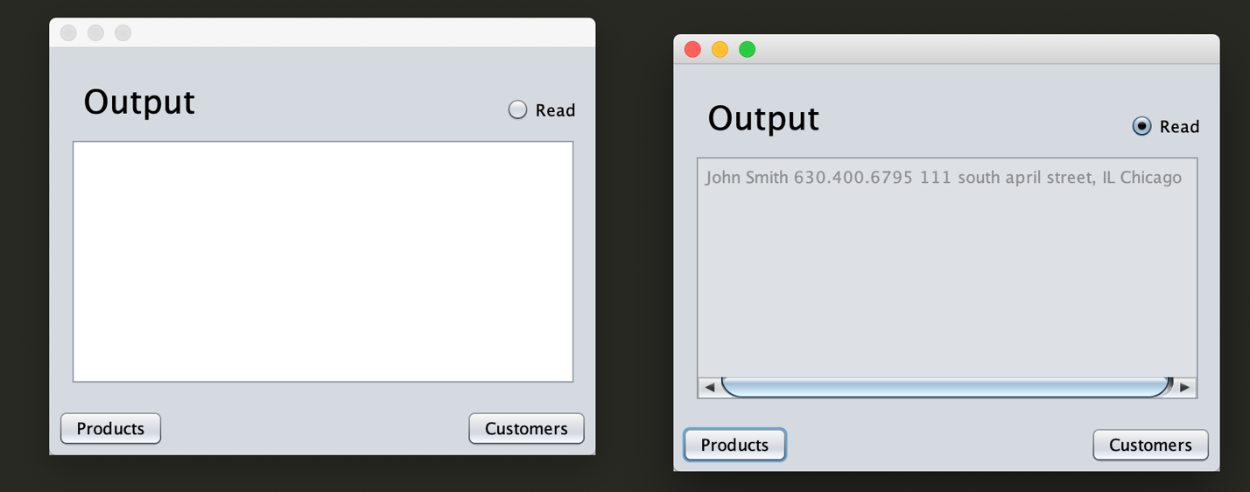

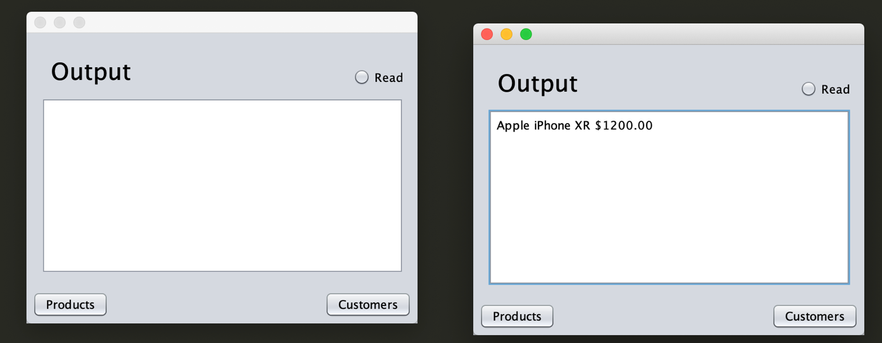

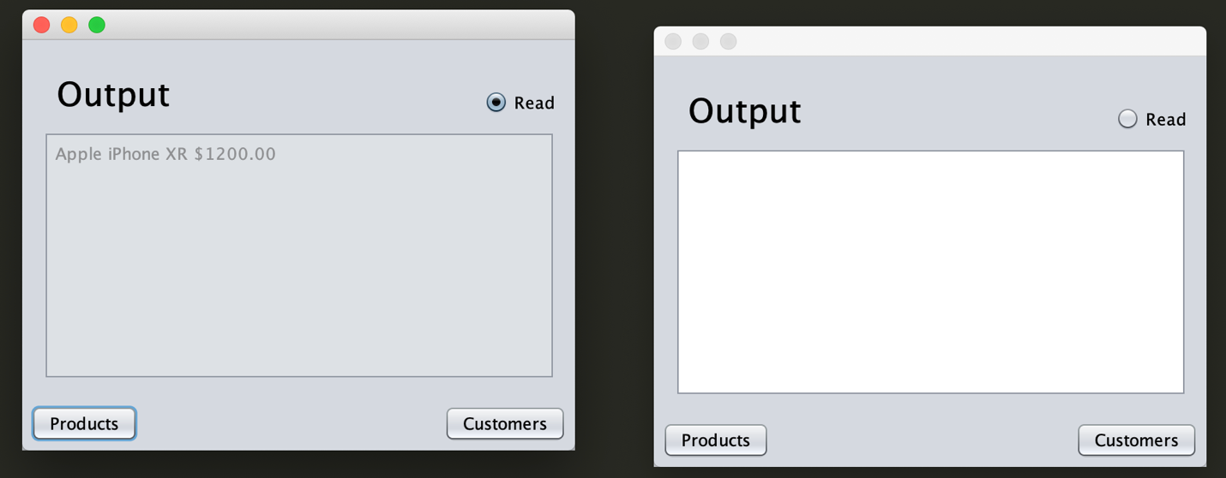

# Unit 3

## Database-Driven Desktop Application

### Screenshots

### Delete

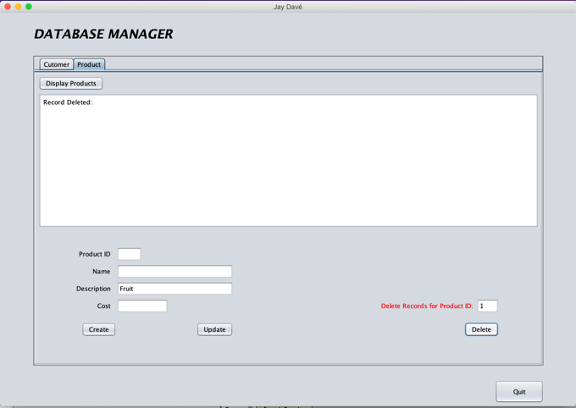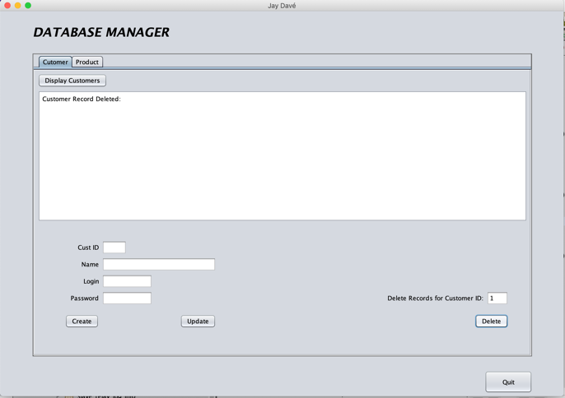

### Create

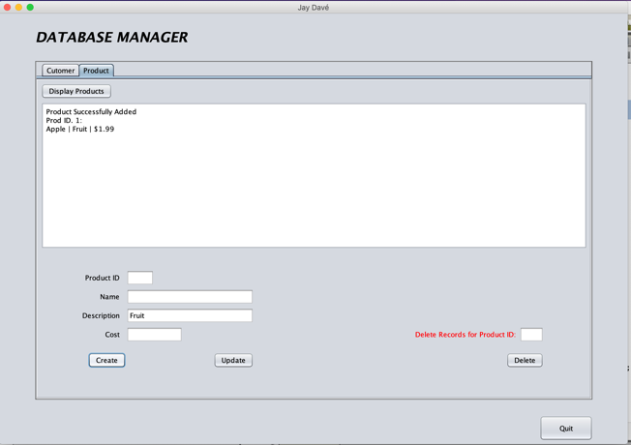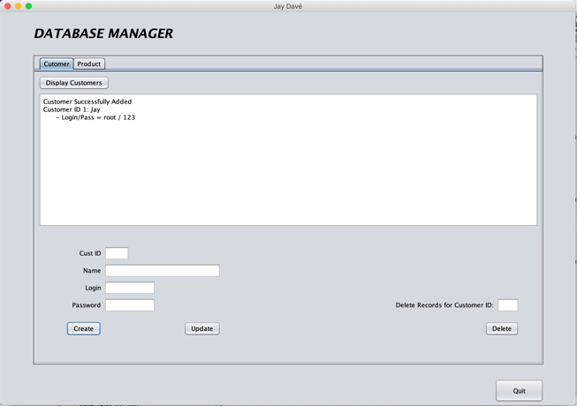

### Update

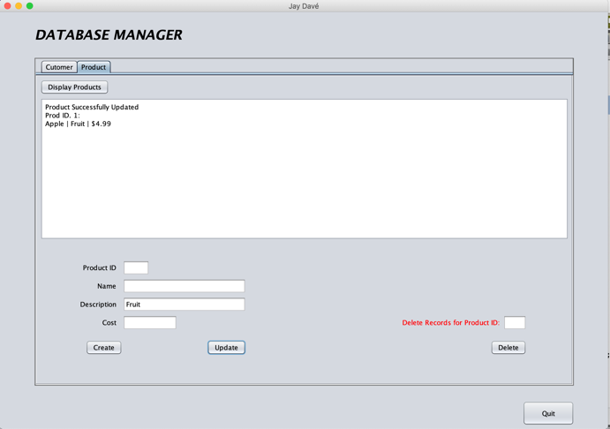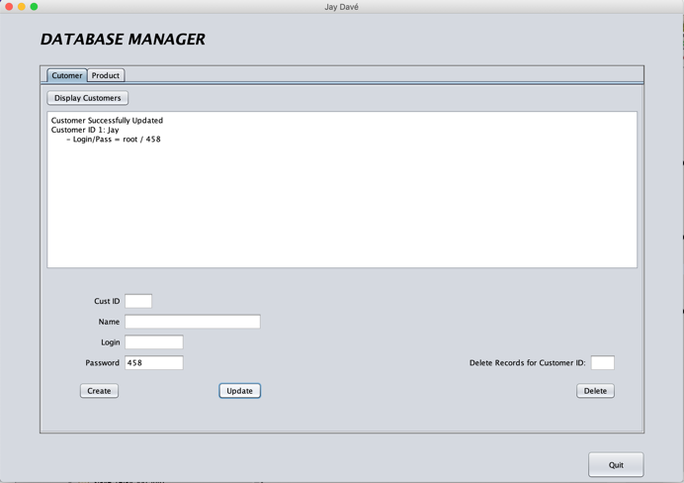

### Read

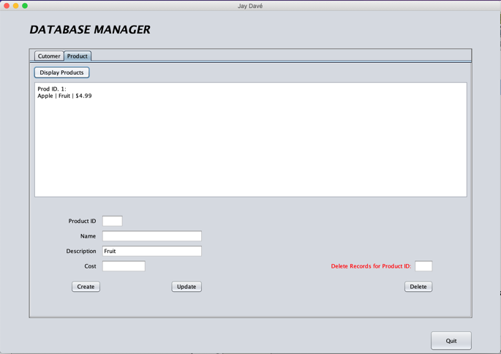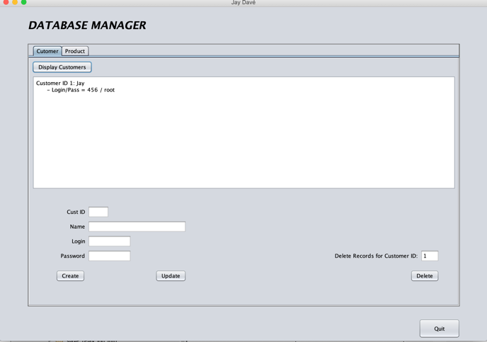

# Unit 4

## Database-Driven Web Applications

### System Architecture

Based off the Desktop application’s architecture the next step in the natural progression of this application is replace the Desktop GUI and replace it with a Web application. The same MySQL database will be used for the create, read, update, delete, (CRUD) functionality of this application.

* Tomcat Server – Will act as the middle layer of technology to serve the backend logic to the front-end / client-side.
* MySQL Database – Will act as the persistence layer of the application which will handle most of the CRUD functionality.
* Web Application – Will be written in Java and utilize maven for build process.

### Diagrams

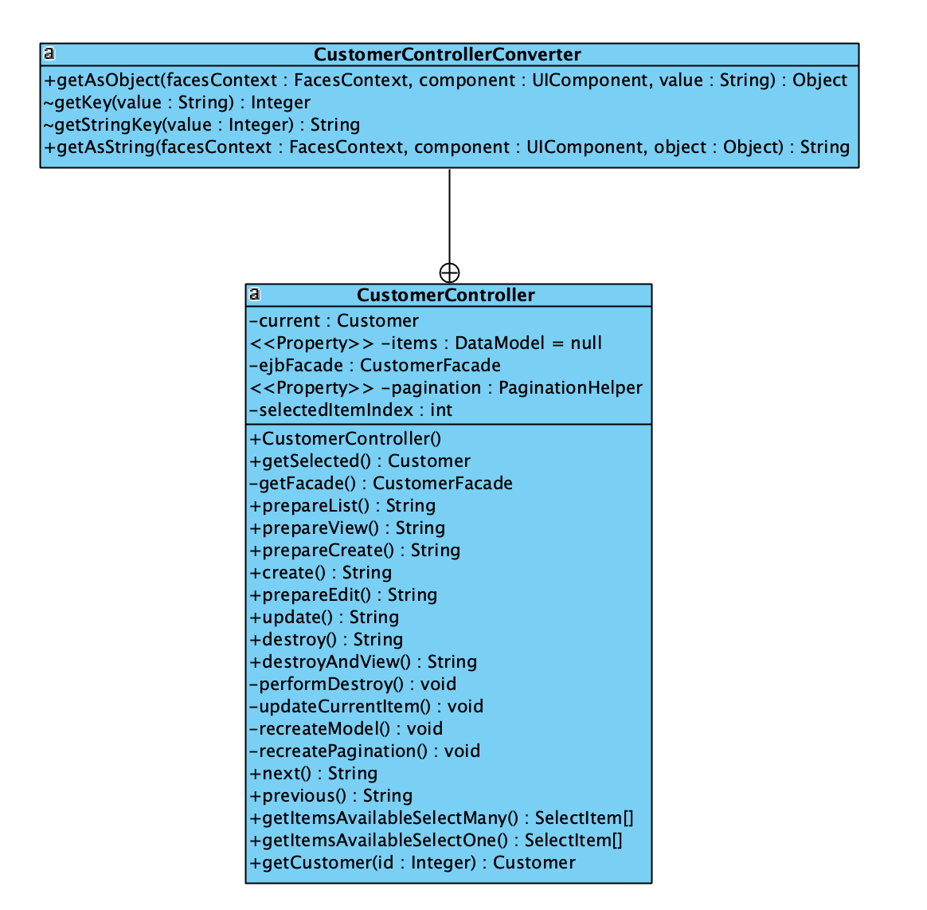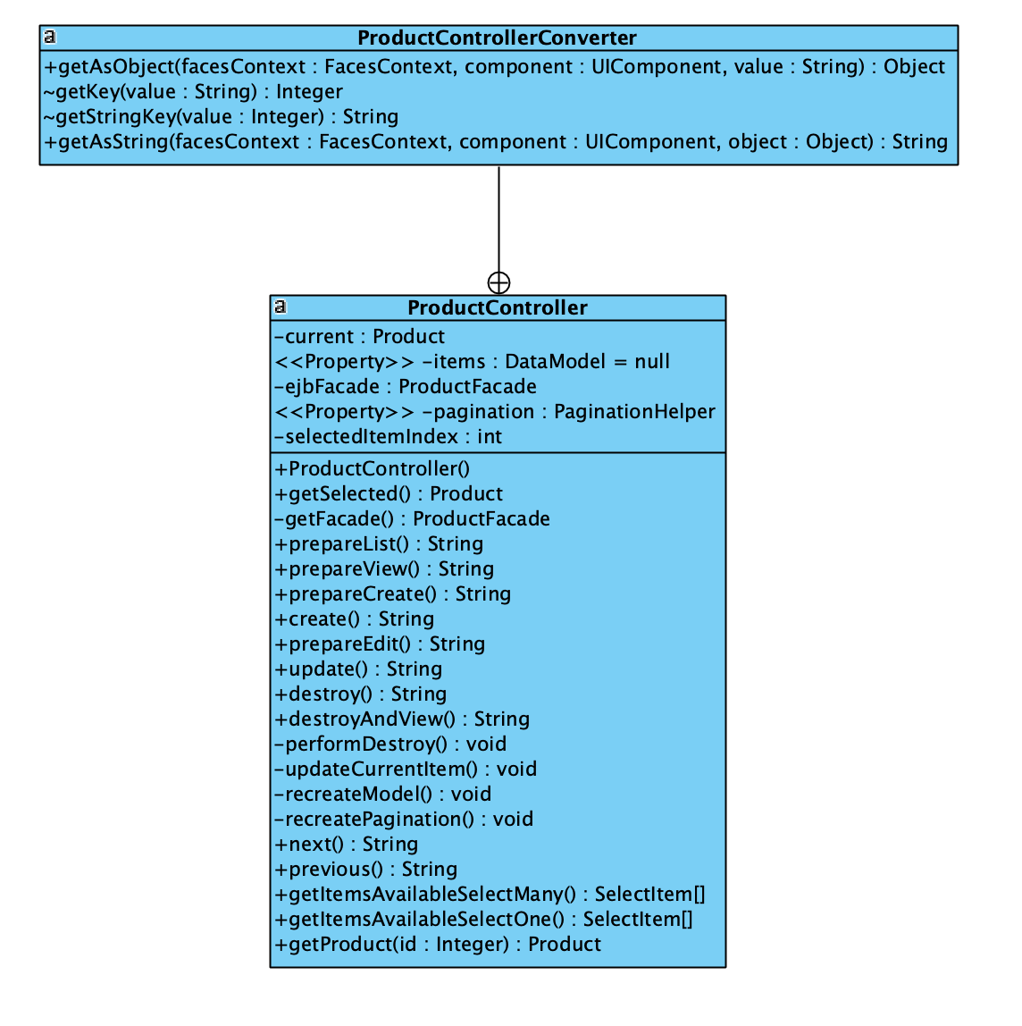

### Future Development Plan

The current implementation of the web server and Web application supports having multiple clients connect to the web server, (this is limited to the resources of the physical or virtual machine that is hosting the Web application and web server). If for example I wanted to deploy my web application to a public cloud provider, (such as AWS or Azure) I would instrument a load balancer to monitor the traffic and virtual computer load, (VM) in order to understand the traffic which my application was experiencing at any given time interval. Based on the current users who were accessing my web application I could configure my load balancers to spin up additional VMs and deploy my application onto them and have my load balancer handle the different proxy or DNS changes so the end-user would not experience any differences when visiting my web application and my environment would be able to scale to the demand of users in an effective manner.

### Q&A

* *Explain how web services are used in the real world. Provide at least 3 real world examples.*
  + Web services are used to bridge the communication between two or more devices on a network.
  + Example 1:
    - SOAP, can be used to XML-based Web services protocol like SMTP for sending emails.
  + Example 2:
    - GoogleSearch API, it is a SOAP-based API for accessing resources in a model for Web Services.
  + Example 3:
    - AWS, or Amazon Web Services – popular commercial cloud provider where hosting a website can be easily achieved.
* *What are the benefits of web services?*
  + Some advantages are the fact of the extensible markup language, (XML). The fact that it is also an industry standard makes it easy to work with and understand.
* *How would you troubleshoot and test a web service? Would you use a debugger? Why or why not?*
  + I would use a monitoring solution to gather metrics and information about my specific web services and how they were impacting my overall application. I would not use a debugger because most debuggers are for code level – where as a monitoring solution would focus on network traffic as well and see how calls were being handled by the different components of my application.
* *Do you think that your client/server application could be enhanced to consume a web service or be used as a web service? Why or why not?*
  + Yes, I do. It would simply be a matter of changing how the server would receive and be able to parse the JSON from a RESTful call. From there the functionality would still remain the same, the only difference would be to change some model mappings or create classes to handle the new JSON objects.
* *Discuss the Java EE technologies you used and the reasons for your choice. Explain how these technologies achieved data persistence.*
  + JDBC – was used in combination with MySQL to allow for access my persistence layer.
  + EJB – used for the business logic and also to help with the Java Persistence API
  + XML – used for creating the eXtensible markup language or HTML

# Unit 5

## Test Plan(s)

### Customer Testing

#### Display Customer Table

|  |  |  |  |  |  |  |  |  |  |  |  |  |
| --- | --- | --- | --- | --- | --- | --- | --- | --- | --- | --- | --- | --- |
|  | | | | | | | | | | | | |
| Test Script ID: | | 001 | | |  | | | | | | | |
| Test Description: | | Connect to web application and display customer table | | | | | | | | | | |
| System: | | Preproduction/Training and Testing | | | Test Type: | | | Functional | | | | |
| Traceability: | | Functionality | | | Priority: | | | Critical | | | | |
| Expected Results: | | Sales database customer table will be displayed to user | | | | | | | | | | |
| Pass/Fail Metric: | | Queried data will return in no more than 4 seconds | | | | | | | | | | |
|  | | | | | | | | | | | | |
|  | |  |  | |  | | |  |  | |  |  |
|  | |  |  | |  | | |  |  | |  |  |
|  | |  |  | |  | | |  |  | |  |  |
|  | |  |  | |  | | |  |  | |  |  |
| Database Manager Test Case | | | | | | | | | | | | |
| Test Script ID: | 001 | | | Test Case ID: | | TC_001 | | | | | | |
| Test Description: | Connect to web application and display customer | | | | | | | | | | | |
| Test Driver ID: | Tester01 | | | System State: | | Preproduction/Training and Testing | | | | | | |
| Input Data Values: | mysql -u ctuonline -p student | | | | | | | | | | | |
| Test Environment: | User LAN-connected Windows desktop connected to localhost | | | | | | | | | | | |
| Req. Traceability: | Module:Functionality | | | | | | | | | | | |
| Test Case Step Instruction | | | | Expected Results | | | Actual Results | | | Pass/Fail | | |
| 1. Open web browser and click link to: <http://localhost:8080/IT351_IP4/faces/index.xhtml> | | | | Web app will load with option to display items | | | Web app loaded | | | Pass | | |
| 1. Click link to show all customer items | | | | List of customers will load to browser | | | Customers Displayed | | | Pass | | |
| 1. Click Index link to return to start page | | | | Browser will return to start page | | | Returned to Index | | | Pass | | |
|  | | | |  | | |  | | |  | | |

*Results from TC_001:*

**Step One**

*Connected to Web Application:*

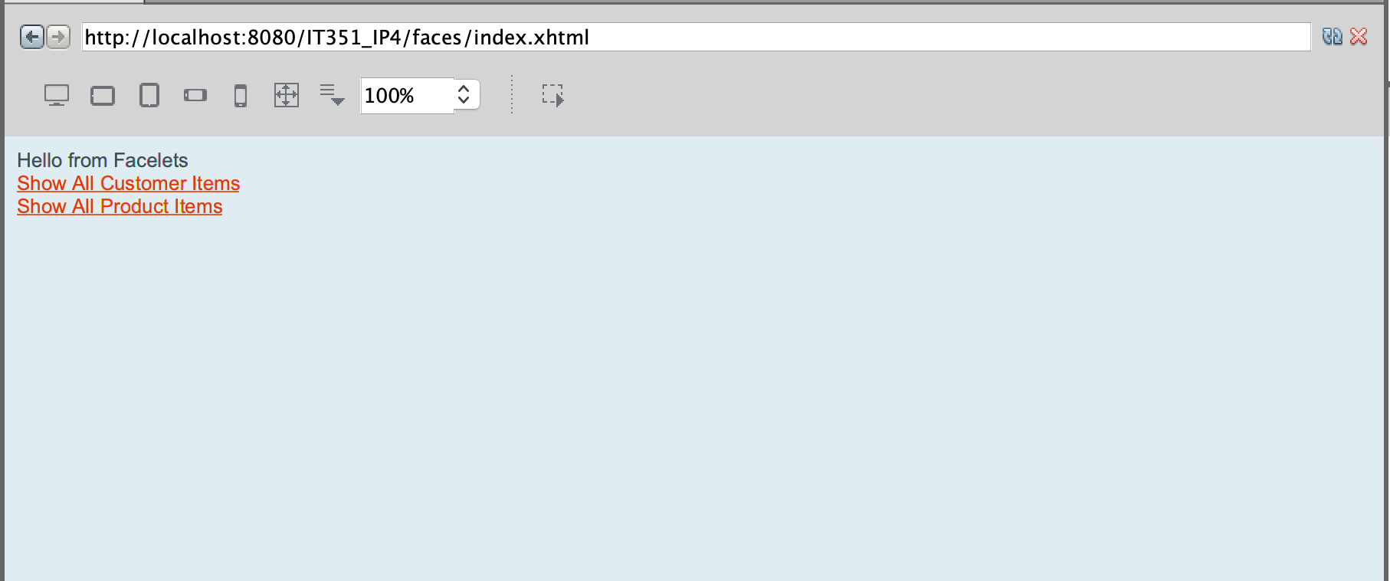

**Step Two**

*Display Customer Items:*

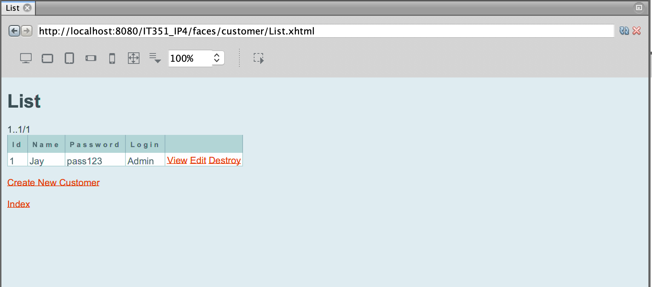

**Step Three**

*Return to Index page*



#### Create A New Customer

|  |  |  |  |  |  |  |  |  |  |  |  |  |
| --- | --- | --- | --- | --- | --- | --- | --- | --- | --- | --- | --- | --- |
| Database Manager Test Script | | | | | | | | | | | | |
| Test Script ID: | | 002 | | |  | | | | | | | |
| Test Description: | | Create new customer table item | | | | | | | | | | |
| System: | | Preproduction/Training and Testing | | | Test Type: | | | Functional | | | | |
| Traceability: | | Module: Functionality | | | Priority: | | | Critical | | | | |
| Expected Results: | | New customer will be created | | | | | | | | | | |
| Pass/Fail Metric: | | New customer ID 5 will be displayed in web browser | | | | | | | | | | |
|  | |  |  | |  | | |  |  | |  |  |
| Database Manager Test Case | | | | | | | | | | | | |
| Test Script ID: | 002 | | | Test Case ID: | | TC_002 | | | | | | |
| Test Description: | Create new customer record | | | | | | | | | | | |
| Test Driver ID: | Tester01 | | | System State: | | Preproduction/Training and Testing | | | | | | |
| Input Data Values: | mysql -u ctuonline -p student //  New customer: ID – 5 / Name – Jim / Login – test / Password - test | | | | | | | | | | | |
| Test Environment: | User LAN-connected Windows desktop connected to localhost | | | | | | | | | | | |
| Req. Traceability: | Module:Functionality | | | | | | | | | | | |
| Test Case Step Instruction | | | | Expected Results | | | Actual Results | | | Pass/Fail | | |
| 1. Open web browser and click link to: <http://localhost:8080/IT351_IP4/faces/index.xhtml> | | | | Web app will load with option to display items | | | Web app loaded | | | Pass | | |
| 1. Click link to show all customer items | | | | List of customers will load to browser | | | Customers Displayed | | | Pass | | |
| 1. Click “Create New Customer” link to add item | | | | Create New Customer webpage will be displayed | | | Page displayed | | | Pass | | |
| 1. Enter new customer values using data values provided above. When entered, click “Save” | | | | “Customer was successfully created” message displayed to page | | | Confirmation Displayed | | | Pass | | |
| 1. Click “Show All Customer Items” link to confirm customer is added | | | | List will contain 5 records, including exact data as provided in data values | | | Item accurately added and displayed to list | | | Pass | | |

*Results from TC_002:*

**Step One**

*Connected to Web Application:*



**Step Two**

*Display Customer Items:*

**

**Step Three**

*Create New Customer:*

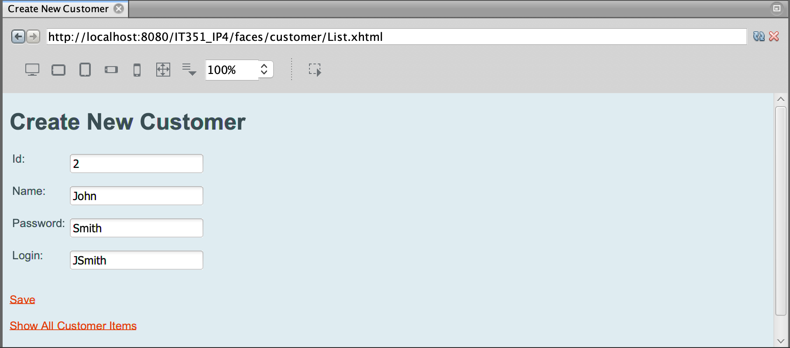

**Step Four**

*Save New Customer Information:*

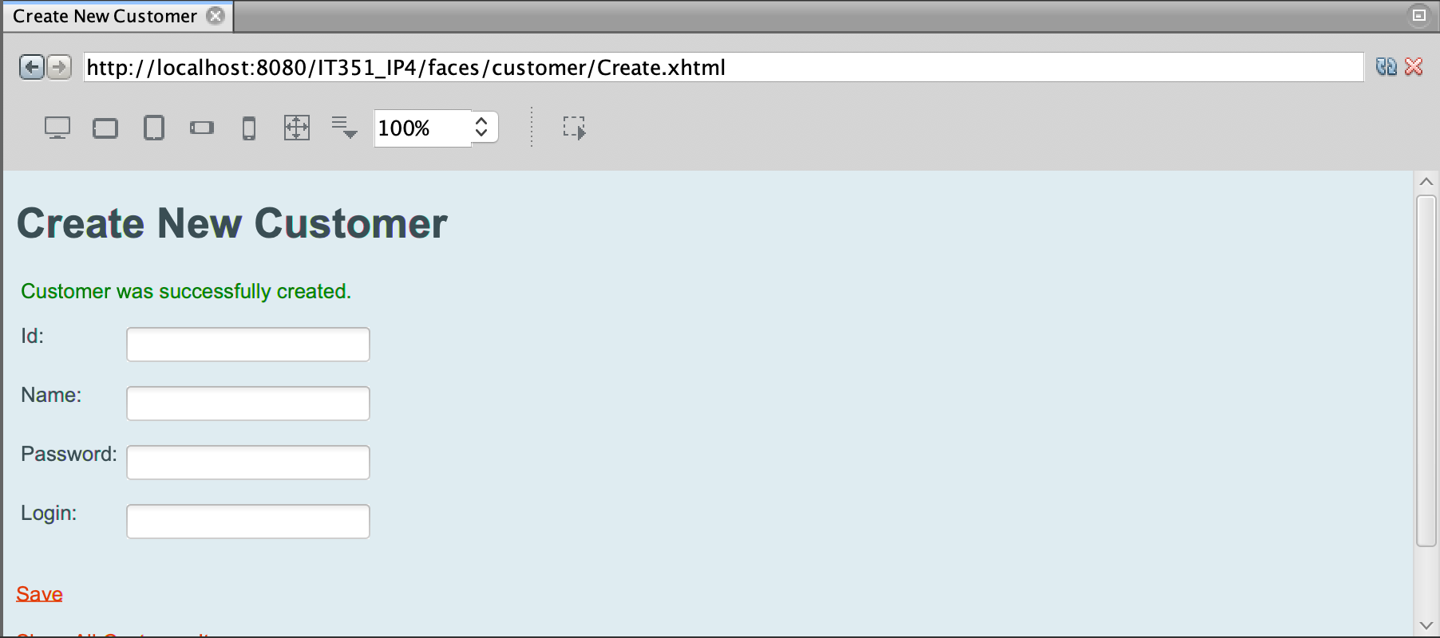

**Step Five**

*Verify New Customer is Added:*

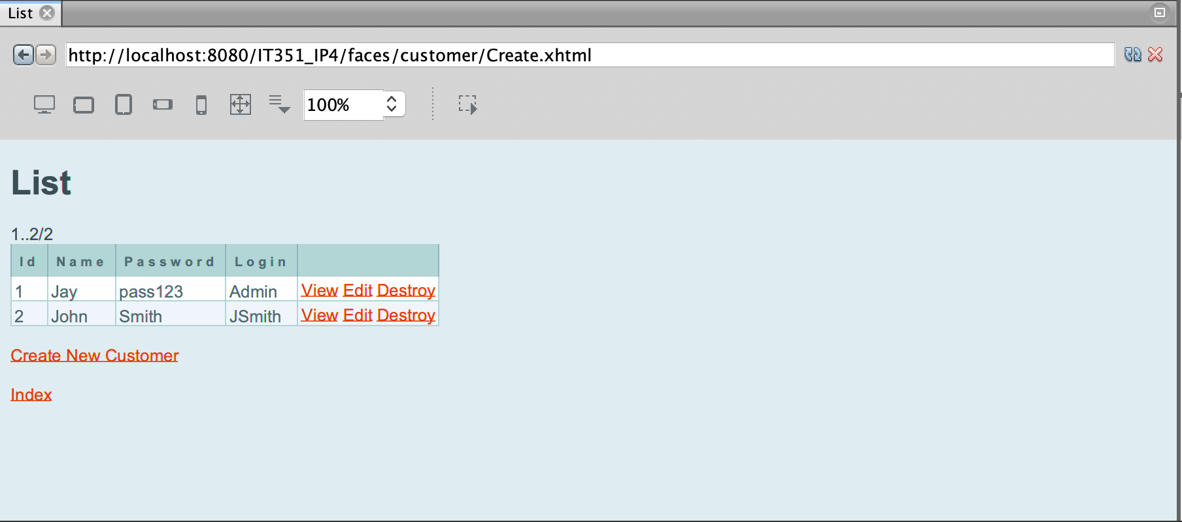

#### Update Customer

|  |  |  |  |  |  |  |  |  |  |  |  |  |
| --- | --- | --- | --- | --- | --- | --- | --- | --- | --- | --- | --- | --- |
| Database Manager Test Script | | | | | | | | | | | | |
| Test Script ID: | | 003 | | |  | | | | | | | |
| Test Description: | | Update an existing customer item | | | | | | | | | | |
| System: | | Preproduction/Training and Testing | | | Test Type: | | | Functional | | | | |
| Traceability: | | Module: Functionality | | | Priority: | | | Critical | | | | |
| Expected Results: | | Existing customer item will be updated and displayed to web page | | | | | | | | | | |
| Pass/Fail Metric: | | Customer 5 will be updated Item will be displayed to web page | | | | | | | | | | |
|  | |  |  | |  | | |  |  | |  |  |
| Database Manager Test Case | | | | | | | | | | | | |
| Test Script ID: | 003 | | | Test Case ID: | | TC_003 | | | | | | |
| Test Description: | Update an existing customer item | | | | | | | | | | | |
| Test Driver ID: | Tester01 | | | System State: | | Preproduction/Training and Testing | | | | | | |
| Input Data Values: | mysql -u ctuonline -p student //  Update customer ID 5 – Jim / Login – ctuonline / Password - student | | | | | | | | | | | |
| Test Environment: | User LAN-connected Windows desktop connected to localhost | | | | | | | | | | | |
| Req. Traceability: | Module: Functionality | | | | | | | | | | | |
| Test Case Step Instruction | | | | Expected Results | | | Actual Results | | | Pass/Fail | | |
| 1. Open web browser and click link to: <http://localhost:8080/IT351_IP4/faces/index.xhtml> | | | | Web app will load with option to display items | | | Web app loaded | | | Pass | | |
| 1. Click link to show all customer items. | | | | List of customers will load to browser | | | Customers Displayed | | | Pass | | |
| 1. Click “Edit” link in row for customer ID 2, Name John. | | | | Edit Customer webpage will be displayed | | | Edit page displayed | | | Pass | | |
| 1. Update login and password using (login) “ctuonline” and (pass) “student” values and click “Save”. | | | | “Customer was successfully updated” message displayed to page | | | Confirmation Displayed with updated item values | | | Pass | | |

*Results from TC_003:*

**Step One**

*Connected to Web Application:*



**Step Two**

*Show All Customers:*

**

**Step Three**

*Select Customer, “John”:*

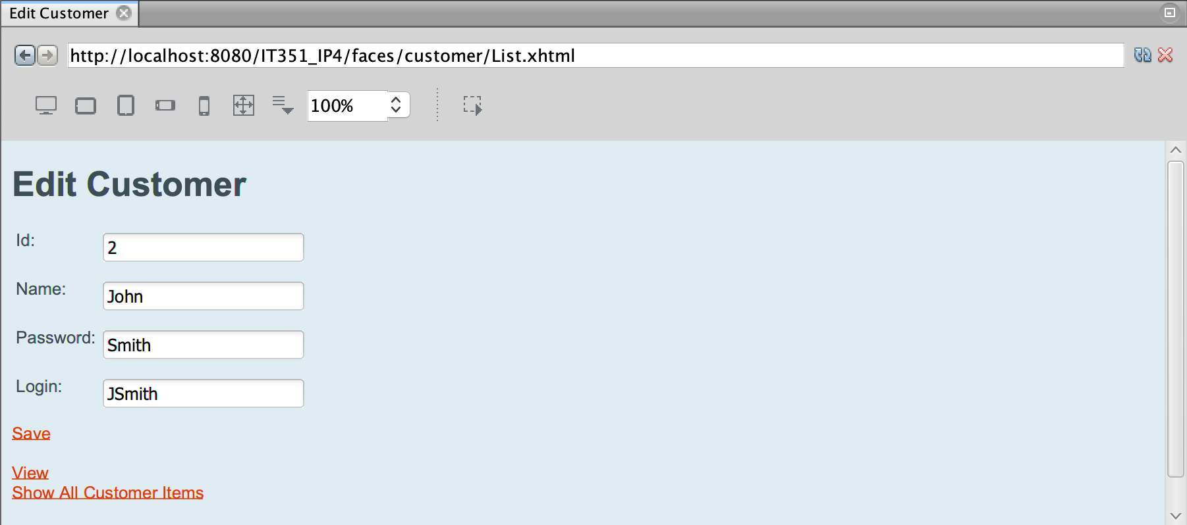

**Step Four**

*Change Customer Login and Password:*

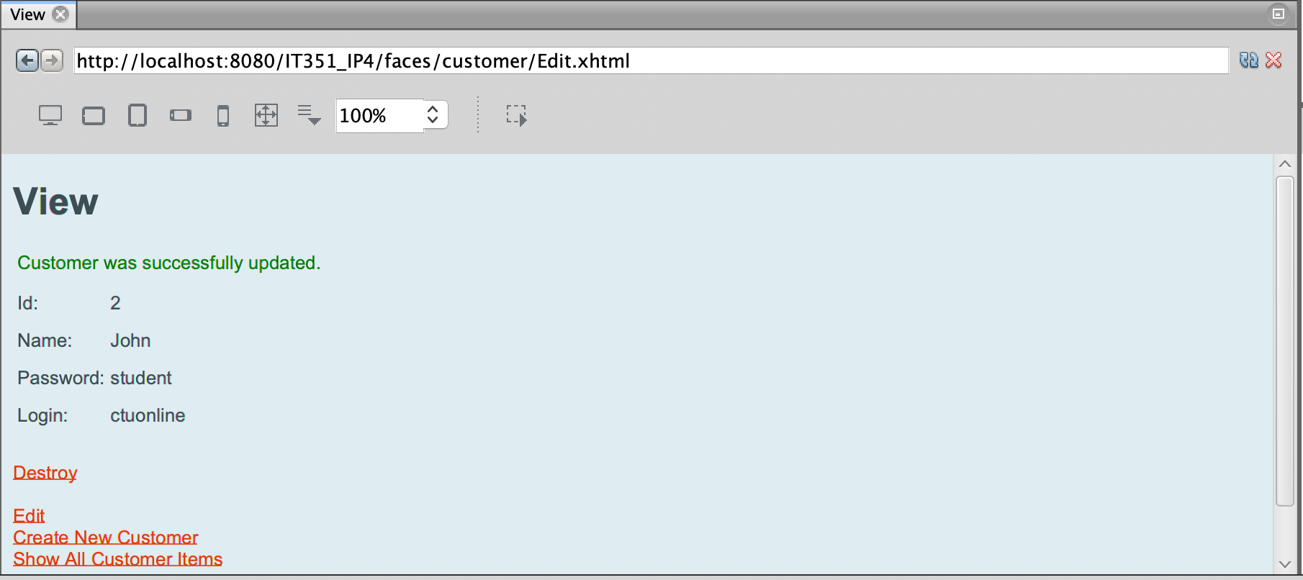

#### Delete Customer

|  |  |  |  |  |  |  |  |  |
| --- | --- | --- | --- | --- | --- | --- | --- | --- |
| Database Manager Test Script | | | | | | | | |
| Test Script ID: | | 004 | |  | | | | |
| Test Description: | | Delete an existing customer item | | | | | | |
| System: | | Preproduction/Training and Testing | | Test Type: | | | Functional | |
| Traceability: | | Module: Functionality | | Priority: | | | Critical | |
| Expected Results: | | Existing customer item will be deleted and verified by viewing list | | | | | | |
| Pass/Fail Metric: | | Item 5 is successfully deleted | | | | | | |
|  | | | | | | | | |
| Database Manager Test Case | | | | | | | | |
| Test Script ID: | 004 | | Test Case ID: | | TC_004 | | | |
| Test Description: | Delete an existing customer item | | | | | | | |
| Test Driver ID: | Tester01 | | System State: | | Preproduction/Training and Testing | | | |
| Input Data Values: | mysql -u ctuonline -p student // | | | | | | | |
| Test Environment: | User LAN-connected Windows desktop connected to localhost | | | | | | | |
| Req. Traceability: | Module: Functionality | | | | | | | |
| Test Case Step Instruction | | | Expected Results | | | Actual Results | | Pass/Fail |
| 1. Open web browser and click link to: <http://localhost:8080/IT351_IP4/faces/index.xhtml> | | | Web app will load with option to display items | | | Web app loaded | | Pass |
| 1. Click link to show all customer items. | | | List of customers will load to browser | | | Customers Displayed | | Pass |
| 1. Click “Destroy” link in row for customer ID 2, Name John. | | | List will update and item associated with ID 5 will be removed. Verification message displayed to webpage along with updated list to show item removal | | | Item removed and updated list displayed. “Customer was successfully deleted” confirmation. | | Pass |

*Results from TC_004:*

**Step One**

*Connected to Web Application:*



**Step Two**

*Show All Customers:*

**

**Step Three**

*Delete Customer, “John”:*

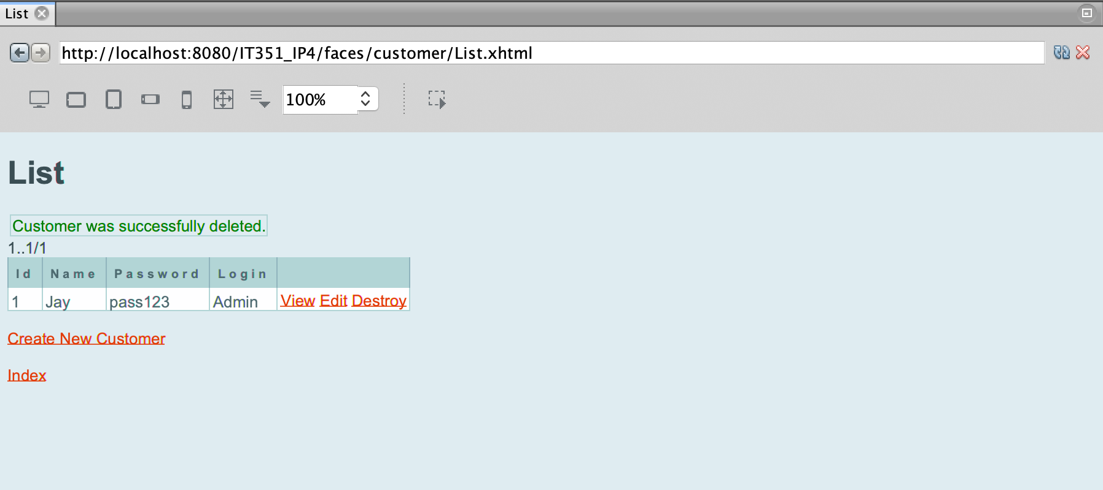

### Product Testing

#### Display Product Table

|  |  |  |  |  |  |  |  |  |  |  |  |  |
| --- | --- | --- | --- | --- | --- | --- | --- | --- | --- | --- | --- | --- |
| Database Manager Test Script | | | | | | | | | | | | |
| Test Script ID: | | 005 | | |  | | | | | | | |
| Test Description: | | Connect to web application and display product table | | | | | | | | | | |
| System: | | Preproduction/Training and Testing | | | Test Type: | | | Functional | | | | |
| Traceability: | | Functionality | | | Priority: | | | Critical | | | | |
| Expected Results: | | Sales database product table will be displayed to user | | | | | | | | | | |
| Pass/Fail Metric: | | Queried data will return in no more than 4 seconds | | | | | | | | | | |
|  | |  |  | |  | | |  |  | |  |  |
| Database Manager Test Case | | | | | | | | | | | | |
| Test Script ID: | 005 | | | Test Case ID: | | TC_005 | | | | | | |
| Test Description: | Connect to web application and display product table | | | | | | | | | | | |
| Test Driver ID: | Tester02 | | | System State: | | Preproduction/Training and Testing | | | | | | |
| Input Data Values: | mysql -u ctuonline -p student | | | | | | | | | | | |
| Test Environment: | User LAN-connected Windows desktop connected to localhost | | | | | | | | | | | |
| Req. Traceability: | Module:Functionality | | | | | | | | | | | |
| Test Case Step Instruction | | | | Expected Results | | | Actual Results | | | Pass/Fail | | |
| 1. Open web browser and click link to: <http://localhost:8080/IT351_IP4/faces/customer/List.xhtml> | | | | Web app will load with option to display items | | | Web app loaded | | | Pass | | |
| 1. Click link to show all Product items | | | | List of products will load to browser | | | Products Displayed | | | Pass | | |
| 1. Click Index link to return to start page | | | | Browser will return to start page | | | Returned to Index | | | Pass | | |

*Results from TC_005:*

**Step One**

*Connected to Web Application:*



**Step Two**

*Show All Products:*

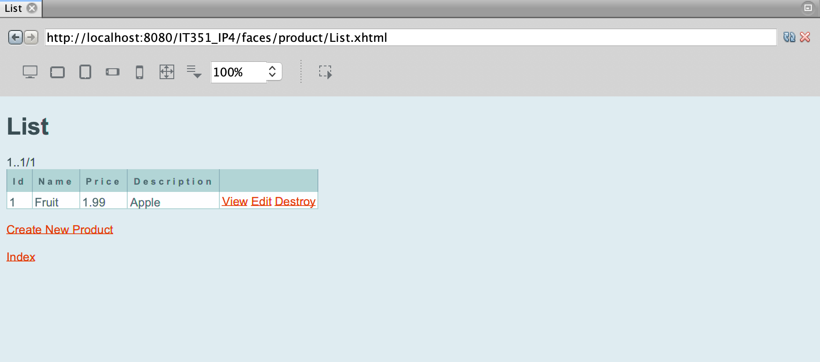

**Step Three**

*Return to Index:*



#### Create Product

|  |  |  |  |  |  |  |  |  |
| --- | --- | --- | --- | --- | --- | --- | --- | --- |
| Database Manager Test Script | | | | | | | | |
| Test Script ID: | | 006 | |  | | | | |
| Test Description: | | Create new product table item | | | | | | |
| System: | | Preproduction/Training and Testing | | Test Type: | | | Functional | |
| Traceability: | | Module: Functionality | | Priority: | | | Critical | |
| Expected Results: | | New product will be created | | | | | | |
| Pass/Fail Metric: | | New product ID 5 will be displayed in web browser | | | | | | |
|  | | | | | | | | |
| Database Manager Test Case | | | | | | | | |
| Test Script ID: | 006 | | Test Case ID: | | TC_006 | | | |
| Test Description: | Create new product record | | | | | | | |
| Test Driver ID: | Tester02 | | System State: | | Preproduction/Training and Testing | | | |
| Input Data Values: | mysql -u ctuonline -p student //  New product:  ID – 5 / Name – AT-AT / Description - Walker / Price - 100 | | | | | | | |
| Test Environment: | User LAN-connected Windows desktop connected to localhost | | | | | | | |
| Req. Traceability: | Module:Functionality | | | | | | | |
| Test Case Step Instruction | | | Expected Results | | | Actual Results | | Pass/Fail |
| 1. Open web browser and click link to: <http://localhost:8080/IT351_IP4/faces/index.xhtml> | | | Web app will load with option to display items | | | Web app loaded | | Pass |
| 1. Click link to show all product items | | | List of products will load to browser | | | products Displayed | | Pass |
| 1. Click “Create New Product” link to add item | | | Create New Product webpage will be displayed | | | Page displayed | | Pass |
| 1. Enter new product values using data values provided above. When entered, click “Save” | | | “Product was successfully created” message displayed to page | | | Confirmation Displayed | | Pass |
| 1. Click “Show All Product Items” link to confirm customer is added | | | List will contain 5 records, including exact data as provided in data values | | | Item accurately added and displayed to list | | Pass |

*Results from TC_006:*

**Step One**

*Connected to Web Application:*



**Step Two**

*Show All Products:*

**

**Step Three**

*Create New Product:*

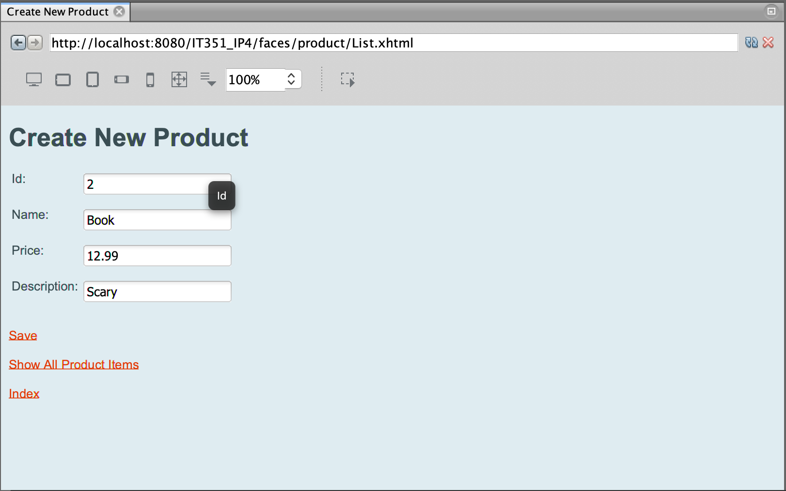

**Step Four***View Newly Created Product:*

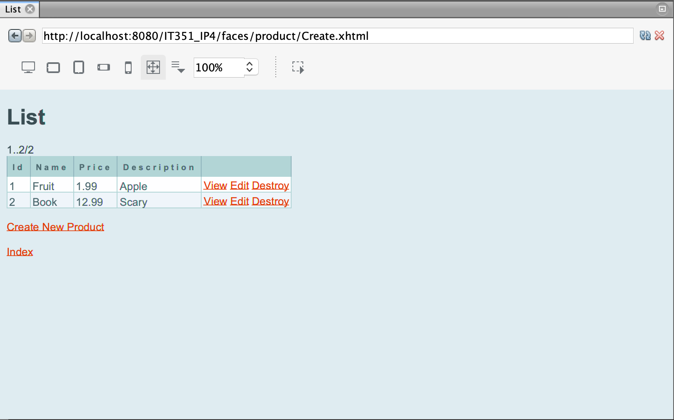

#### Update Product

|  |  |  |  |  |  |  |  |  |
| --- | --- | --- | --- | --- | --- | --- | --- | --- |
| Database Manager Test Script | | | | | | | | |
| Test Script ID: | | 007 | |  | | | | |
| Test Description: | | Update an existing product item 5 | | | | | | |
| System: | | Preproduction/Training and Testing | | Test Type: | | | Functional | |
| Traceability: | | Module: Functionality | | Priority: | | | Critical | |
| Expected Results: | | Existing product item will be updated and displayed to web page | | | | | | |
| Pass/Fail Metric: | | Product 5 will be updated Item will be displayed to web page | | | | | | |
|  | | | | | | | | |
| Database Manager Test Case | | | | | | | | |
| Test Script ID: | 007 | | Test Case ID: | | TC_007 | | | |
| Test Description: | Update an existing product item 5 | | | | | | | |
| Test Driver ID: | Tester02 | | System State: | | Preproduction/Training and Testing | | | |
| Input Data Values: | mysql -u ctuonline -p student //  Update product ID 5 – AT-AT with updated values:  description – Imperial Walker/ Price - 999 | | | | | | | |
| Test Environment: | User LAN-connected Windows desktop connected to localhost | | | | | | | |
| Req. Traceability: | Module: Functionality | | | | | | | |
| Test Case Step Instruction | | | Expected Results | | | Actual Results | | Pass/Fail |
| 1. Open web browser and click link to: <http://localhost:8080/IT351_IP4/faces/index.xhtml> | | | Web app will load with option to display items | | | Web app loaded | | Pass |
| 1. Click link to show all product items. | | | List of products will load to browser | | | products Displayed | | Pass |
| 1. Click “Edit” link in row for product ID 2, Name “Book”. | | | Edit product webpage will be displayed | | | Edit page displayed | | Pass |
| 1. Update description and price using (description) “Comedy” and (price) “12.02” values and click “Save”. | | | “Product was successfully updated” message displayed to page | | | Confirmation Displayed with updated item values | | Pass |

*Results from TC_007:*

**Step One**

*Connected to Web Application:*



**Step Two**

*Show All Products:*

**

**Step Three**

*Edit Existing Product:*

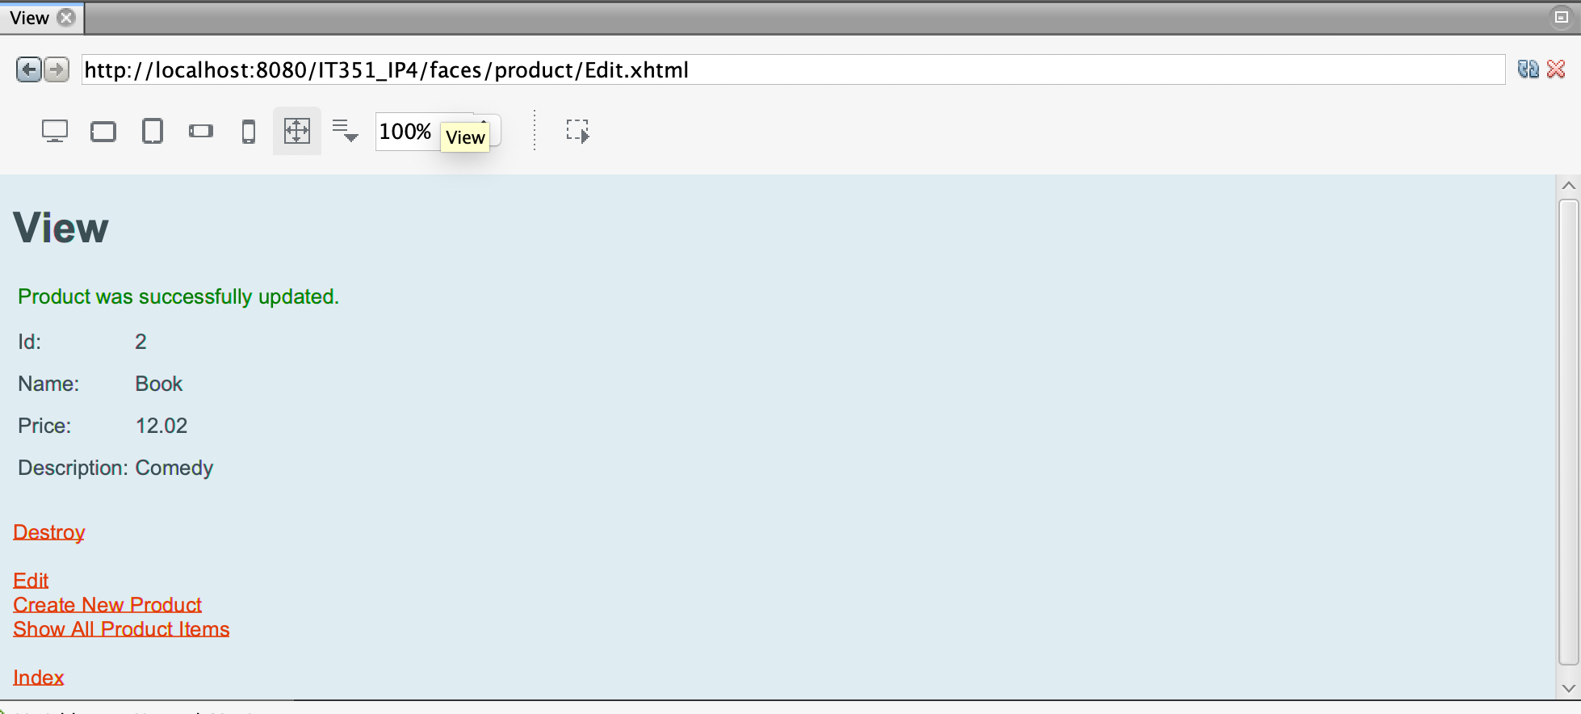

#### Delete Product

|  |  |  |  |  |  |  |  |  |
| --- | --- | --- | --- | --- | --- | --- | --- | --- |
| Database Manager Test Script | | | | | | | | |
| Test Script ID: | | 008 | |  | | | | |
| Test Description: | | Delete an existing product item | | | | | | |
| System: | | Preproduction/Training and Testing | | Test Type: | | | Functional | |
| Traceability: | | Module: Functionality | | Priority: | | | Critical | |
| Expected Results: | | Existing product item will be deleted and verified by viewing list | | | | | | |
| Pass/Fail Metric: | | Item 5 is successfully deleted | | | | | | |
|  | | | | | | | | |
| Database Manager Test Case | | | | | | | | |
| Test Script ID: | 008 | | Test Case ID: | | TC_008 | | | |
| Test Description: | Delete an existing product item | | | | | | | |
| Test Driver ID: | Tester02 | | System State: | | Preproduction/Training and Testing | | | |
| Input Data Values: | mysql -u ctuonline -p student // | | | | | | | |
| Test Environment: | User LAN-connected Windows desktop connected to localhost | | | | | | | |
| Req. Traceability: | Module: Functionality | | | | | | | |
| Test Case Step Instruction | | | Expected Results | | | Actual Results | | Pass/Fail |
| 1. Open web browser and click link to: <http://localhost:8080/IT351_IP4/faces/index.xhtml> | | | Web app will load with option to display items | | | Web app loaded | | Pass |
| 1. Click link to show all product items. | | | List of products will load to browser | | | Products Displayed | | Pass |
| 1. Click “Destroy” link in row for product ID 2, Name ”Book”. | | | List will update and item associated with ID 5 will be removed. Verification message displayed to webpage along with updated list to show item removal | | | Item removed and updated list displayed. “Product was successfully deleted” confirmation. | | Pass |

*Results from TC_008:*

**Step One**

*Connected to Web Application:*



**Step Two**

*Show All Products:*

**

**Step Three**

*Delete A Product:*

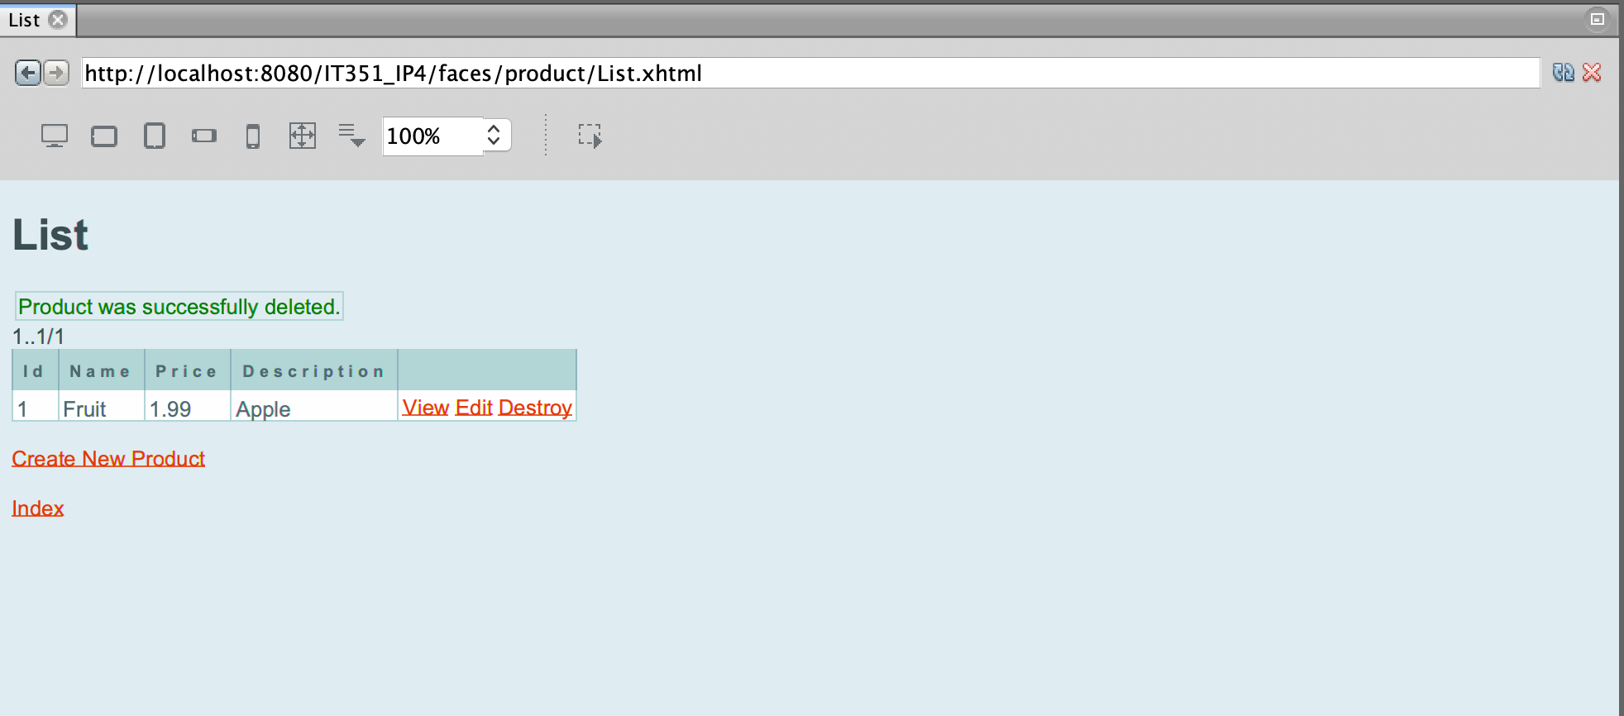

## User Manual Requirements

### Setup

In order to begin please download the solution for IT351_IP4. Once the folder has been downloaded to your local computer – proceed to open the solution within NetBeans Java IDE. In case the solution does not load with the proper configuration to connect to MySQL please enter the following information as seen below:

* Hostname – localhost
* Port – 3306
* Username – ctuonline
* Password – student

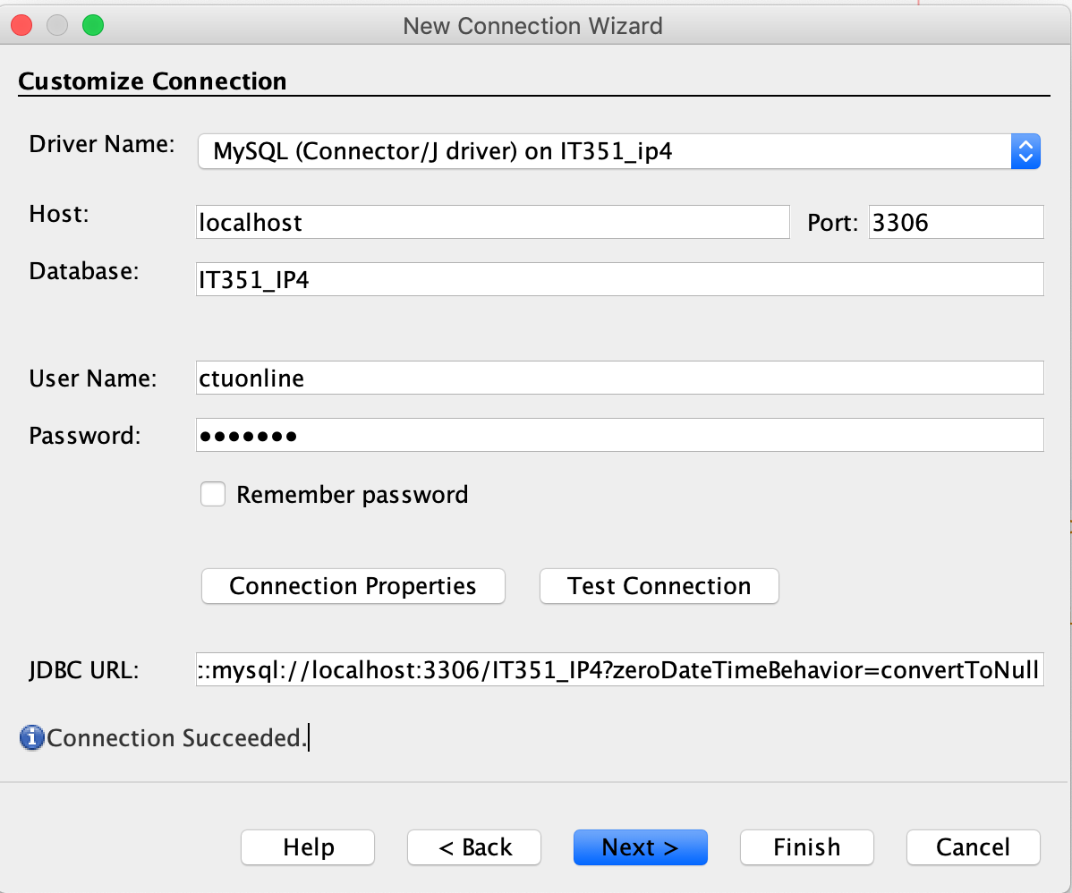

*Note: If there are any issues with connecting to the Database with an error around `CDT` time zones, please run the following commands to remediate this MySQL error:*

SET @@global.time_zone = '+00:00';

SET @@session.time_zone = '+00:00';

### SQL Script(s)

#### Create User & Grant Permissions

CREATE USER 'ctuonline'@'localhost' IDENTIFIED BY ‘student';

grant all privileges on `IT351_IP4`.* to 'ctuonline'@'localhost';

#### Create Database

CREATE DATABASE IT351_IP4

#### Create Customer Table

CREATE TABLE IT351_IP4.customer (

id int(10) NOT NULL,

name varchar(30),

password varchar(30),

login varchar(30),

PRIMARY KEY (id)

) ENGINE=InnoDB DEFAULT CHARSET=utf8;

#### Create Product Table

CREATE TABLE IT351_IP4.product (

id int(10) NOT NULL auto_increment,

name varchar(30),

price decimal(8,2),

description varchar(120),

PRIMARY KEY (id)

) ENGINE=InnoDB DEFAULT CHARSET=utf8;

#### Seed Customer Table

INSERT INTO IT351_IP4.customer(id, name, password, login) VALUES (1, 'Jay', 'pass123', 'Admin');

#### Seed Product Table

INSERT INTO IT351_IP4.product(id, name, price, description) VALUES (1, 'Fruit', 1.99, 'Apple');

To this point you will have downloaded the source code and setup NetBeans Java IDE to connect to the MySQL J Connector instance, which was included with the source code. The above MySQL scripts will assist in creating the proper user and granting the correct access rights as well as created the Database and respected tables, while offering some optional seed data for the Customer and Product tables.

To start the application right-click on the solution name, IT351_IP4 and click on the “Run”:

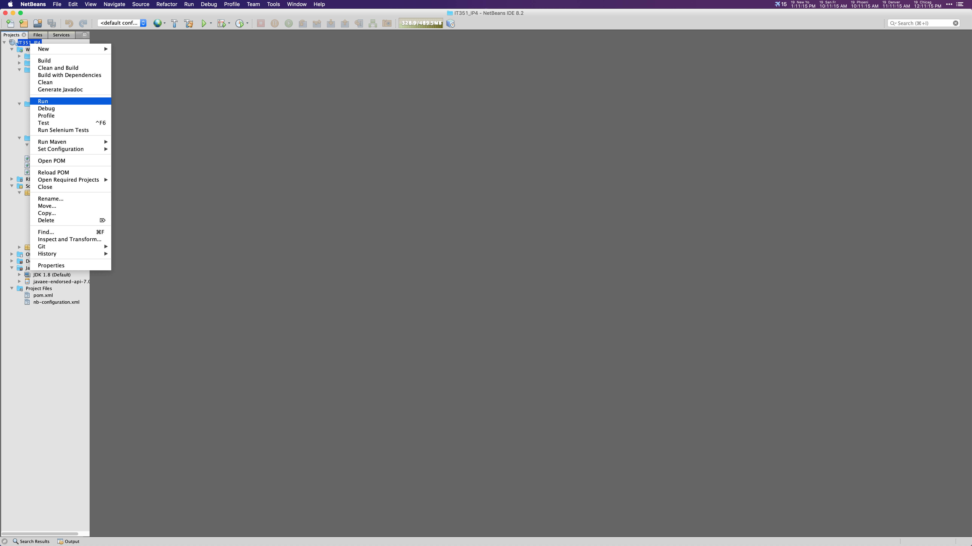

When the application loads and renders correctly, take a look at the output console. It should look like the following:

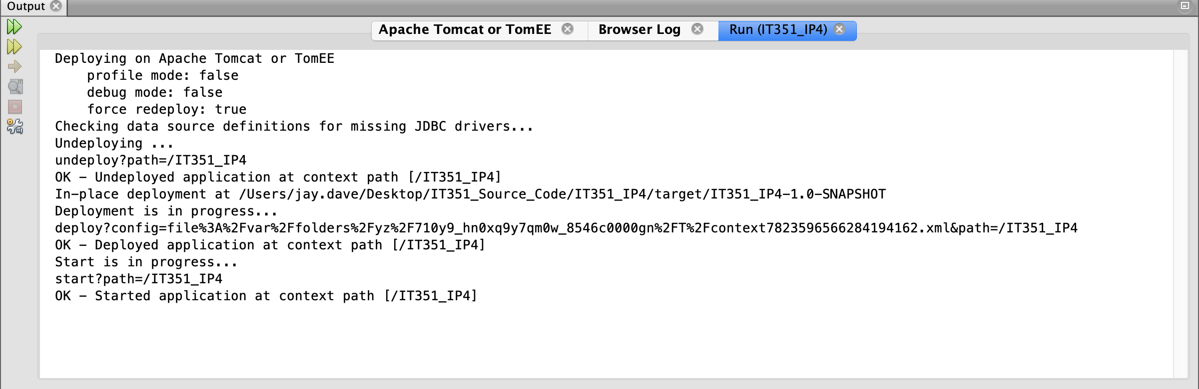

Now that the application has been successfully started, navigate to a local Web browser of your choosing and visit the following address: <http://localhost:8080/IT351_IP4/>. When this address is entered into the Web browser you will be taken to the Index page, (as seen below).   
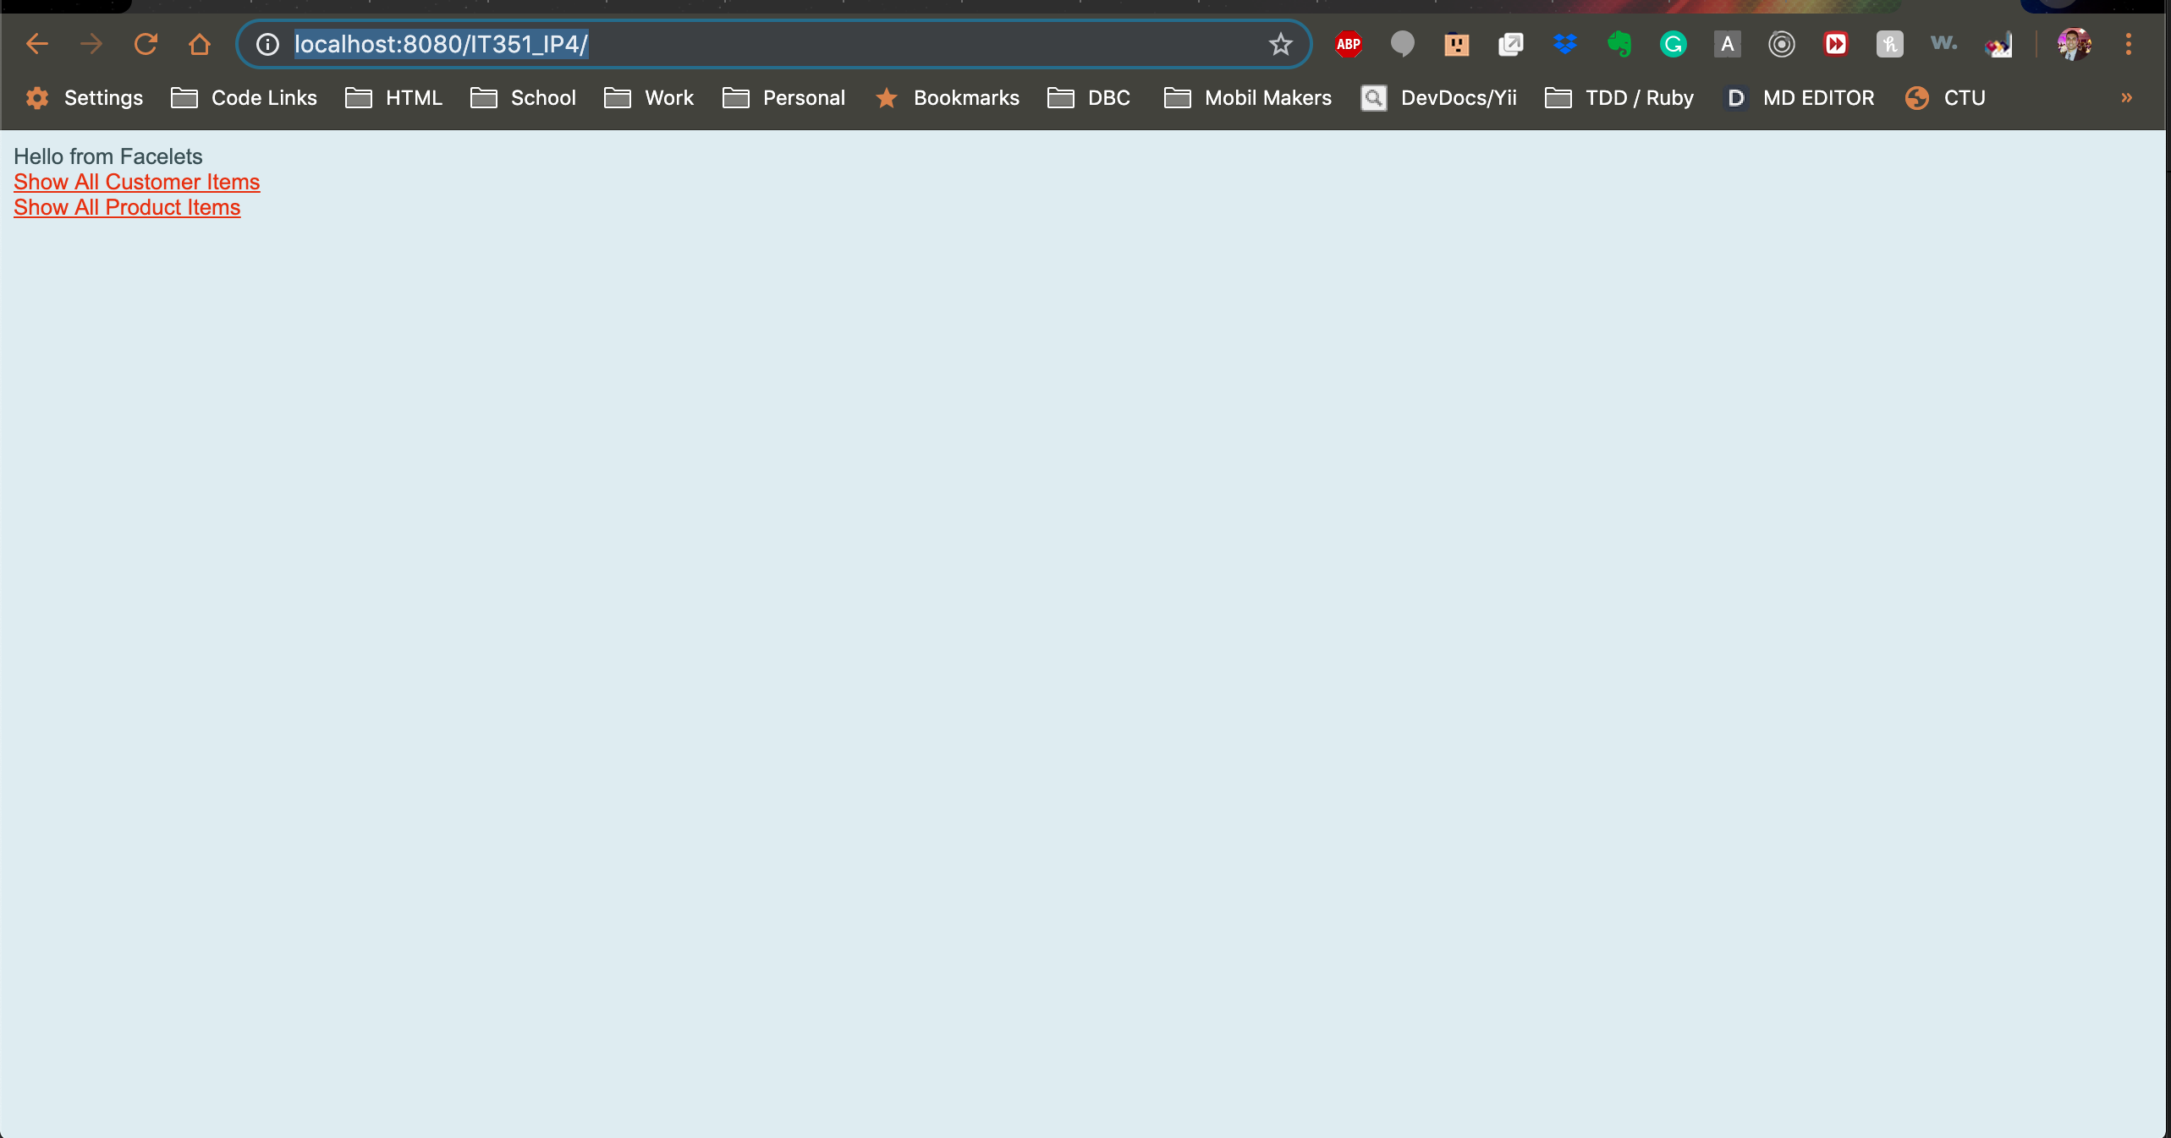

#### CRUD Functionality

As mentioned above when navigating to <http://localhost:8080/IT351_IP4/> within a Web browser of your choosing you will see the following Index page.



*Read all Customers Entries:*

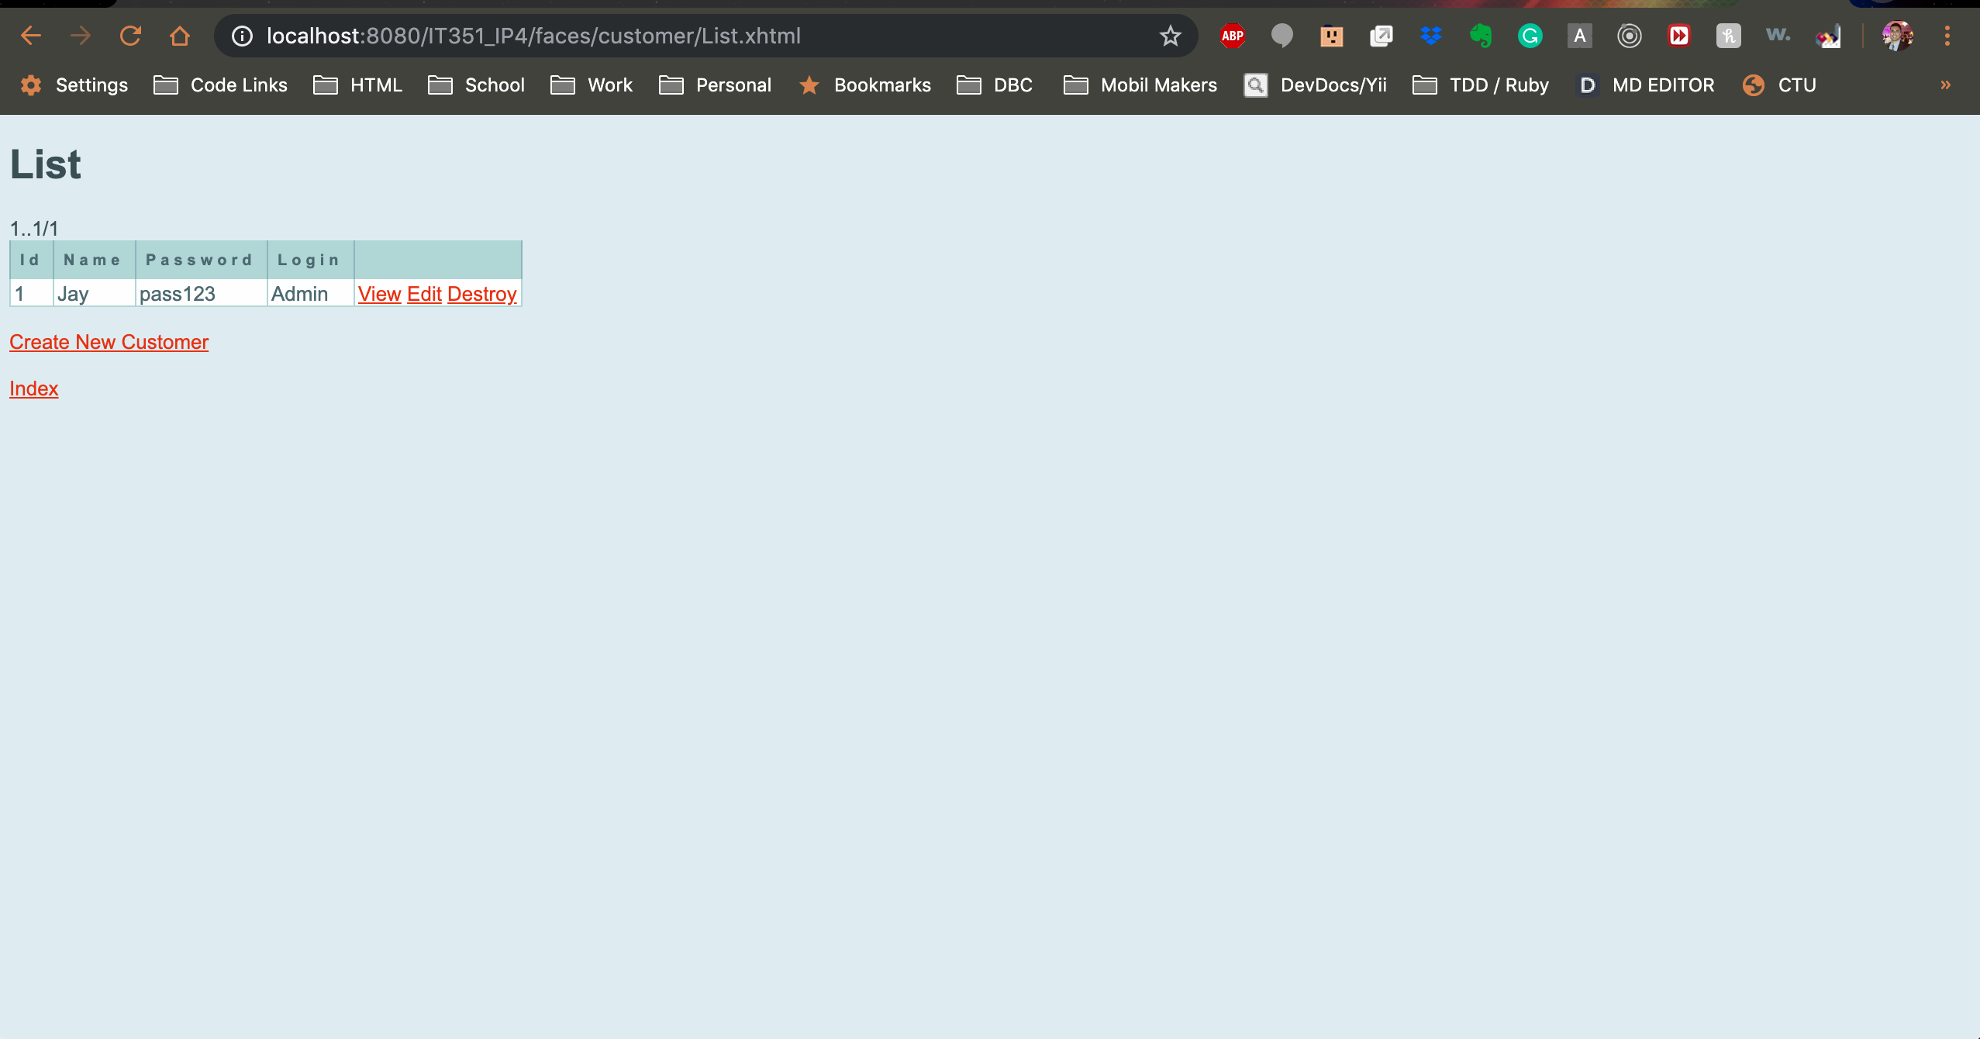

*Create A New Customer:*

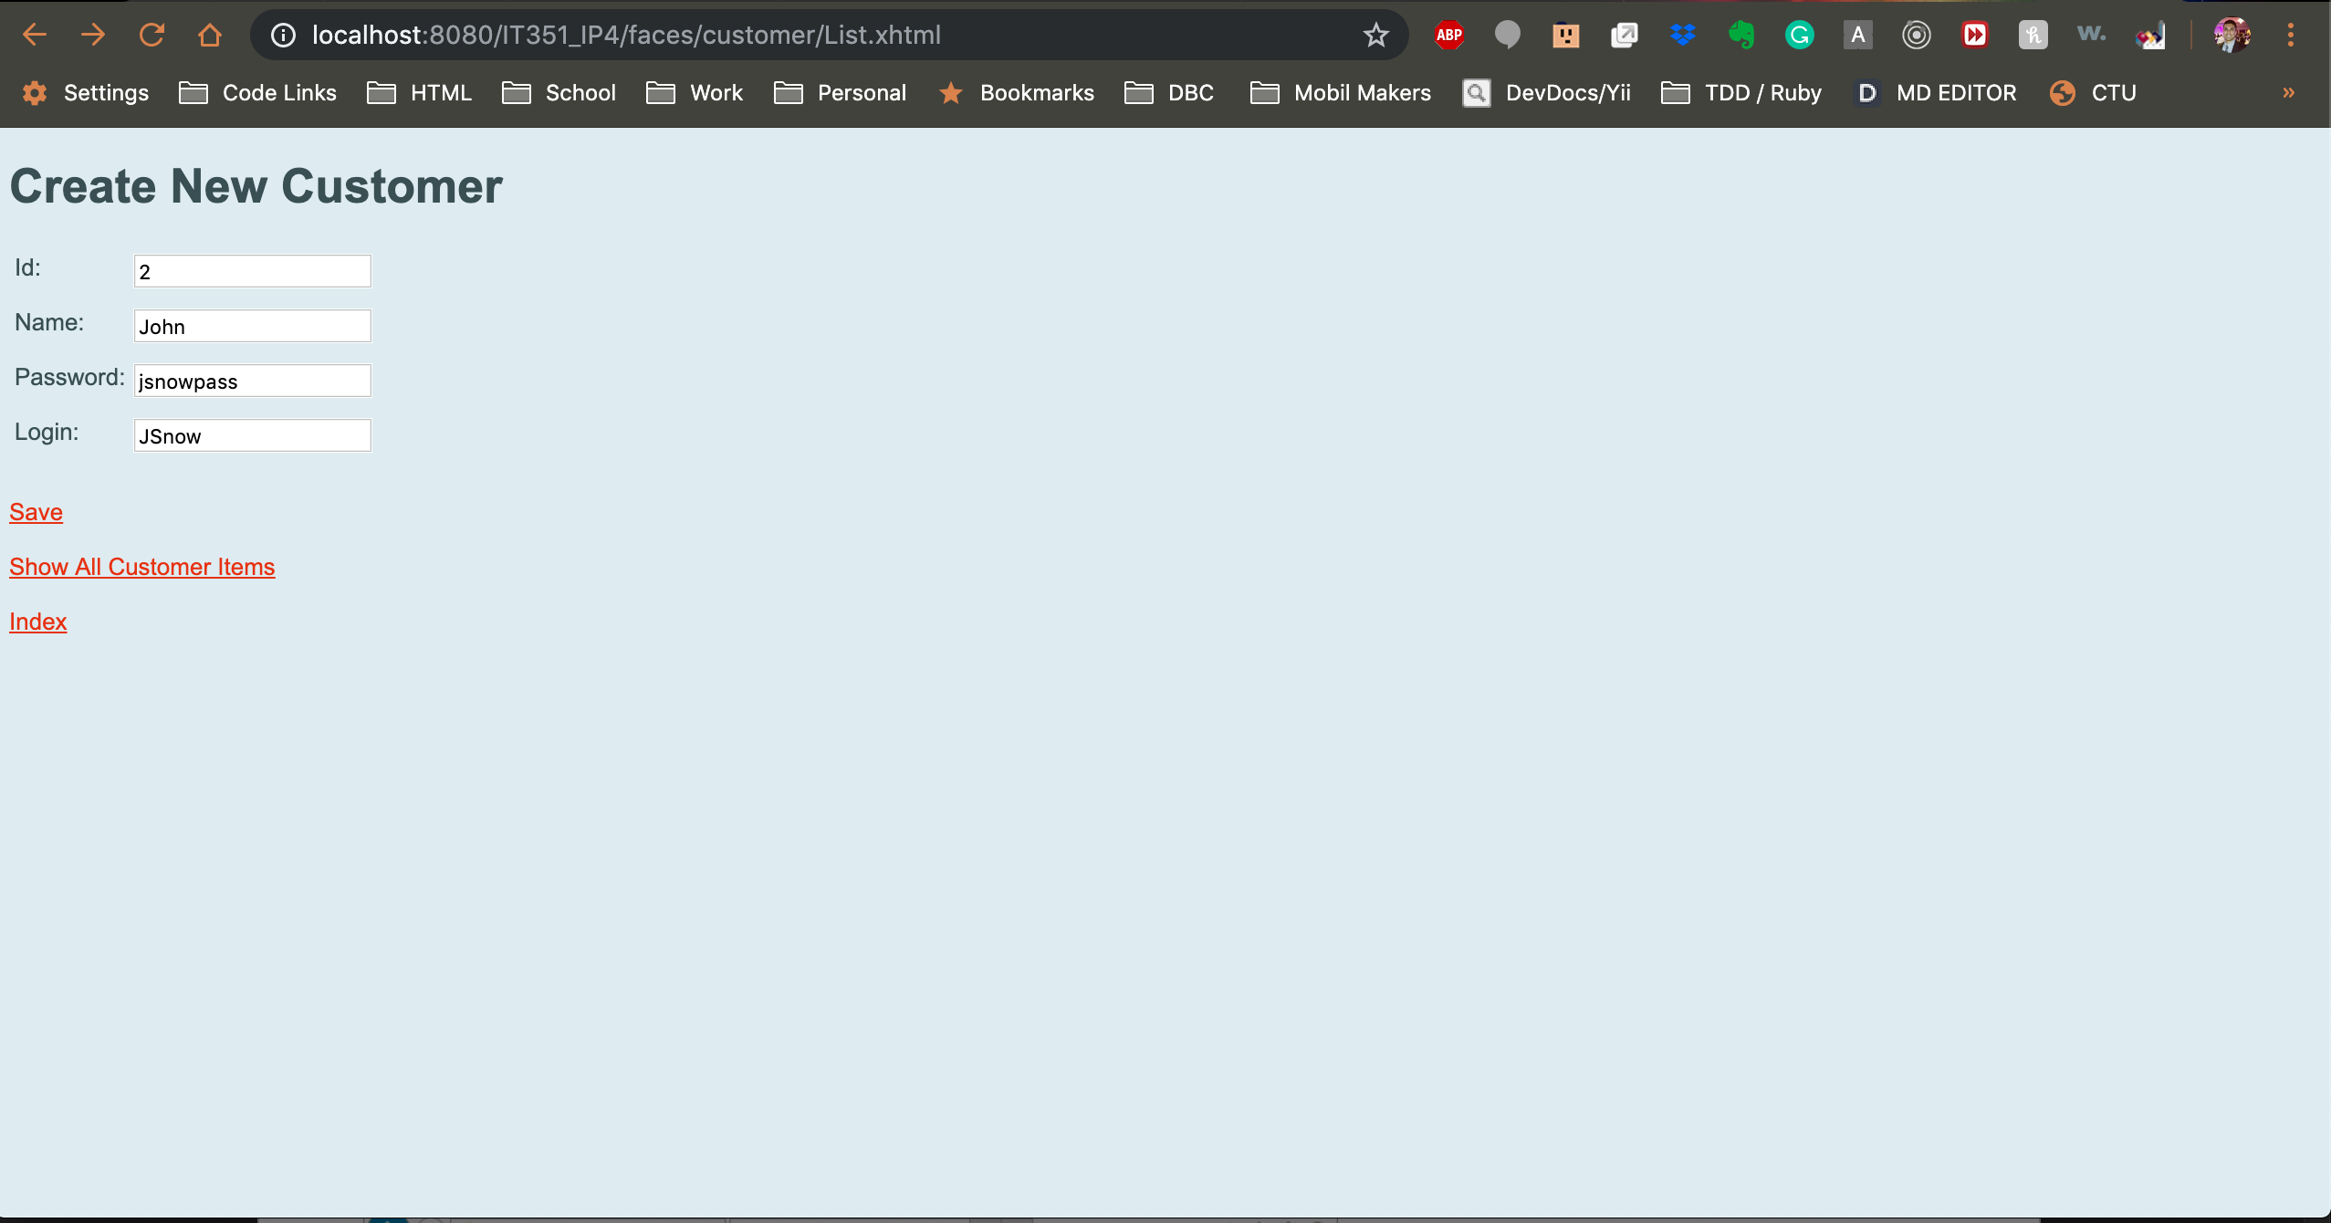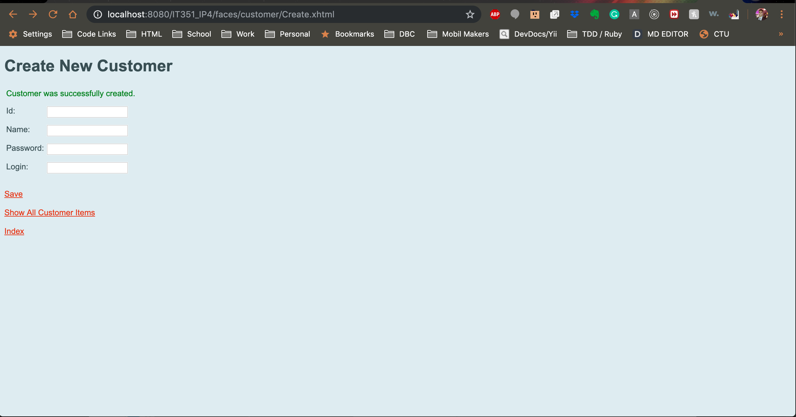

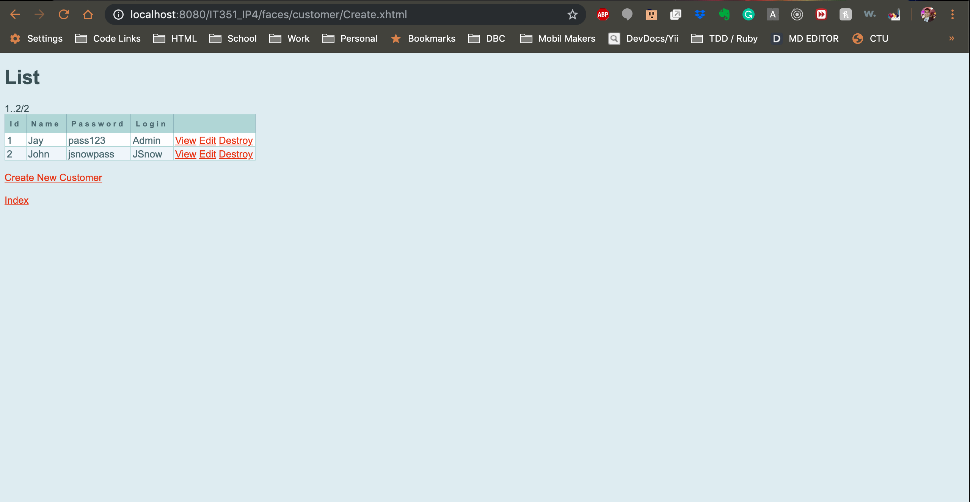

Illustrated above, once the table records load from the Customer table or the Product table you will see the following options:

* Index: This link will return to the Index page where you can choose from Product or Customer
* Create New: Add a new entry via a Web Form to the respected tables.
* View: Review details from a specific entry
* Edit: Change the value of an existing record
* Destroy: Delete the record from the correct table(s)

*Update Existing Customer Record:*

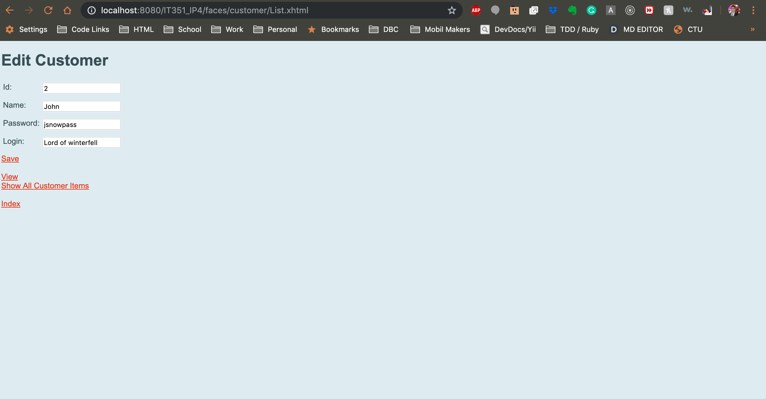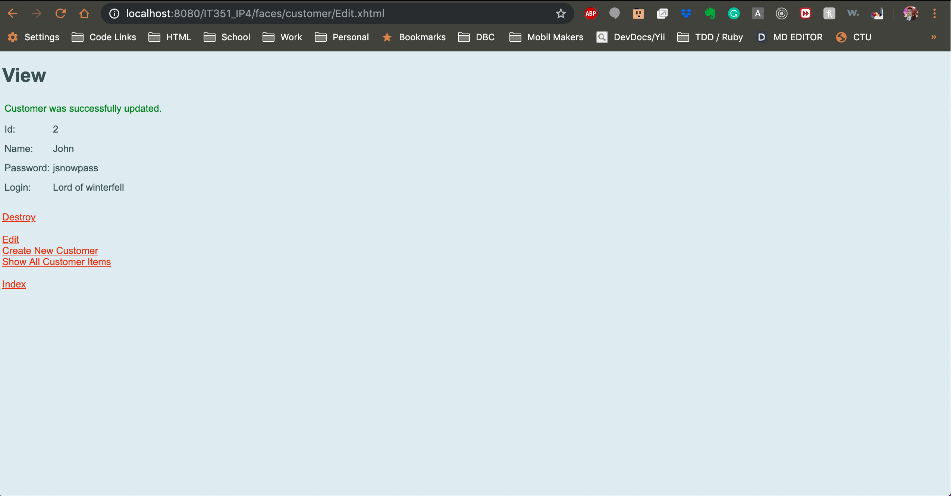

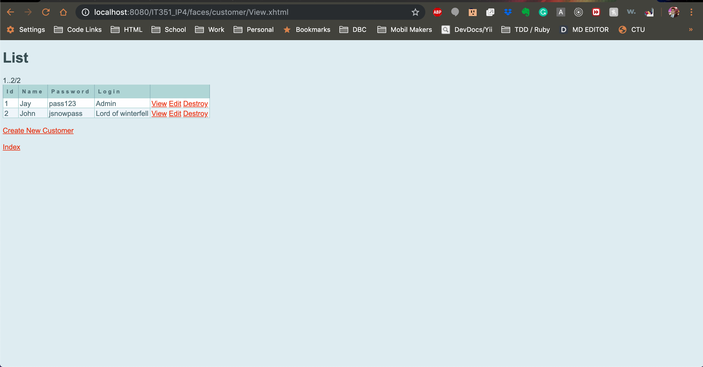

*Delete Existing Customer Record:*

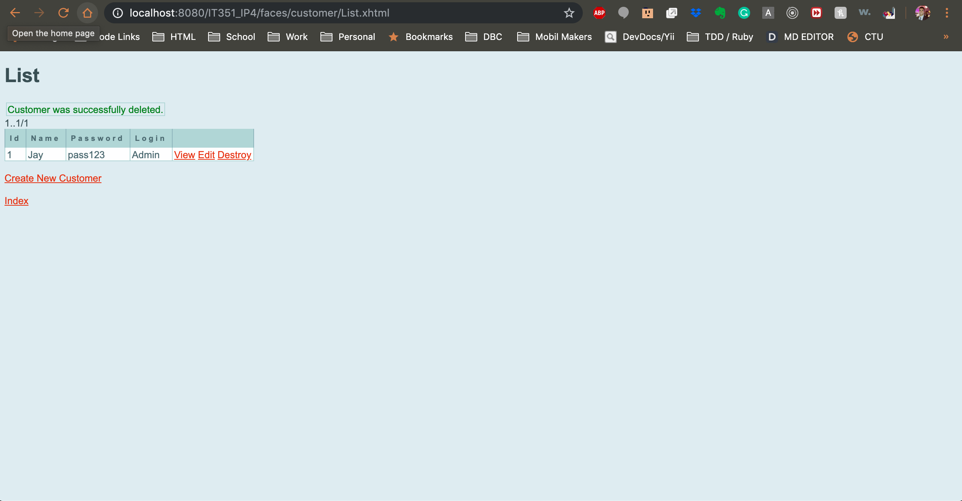

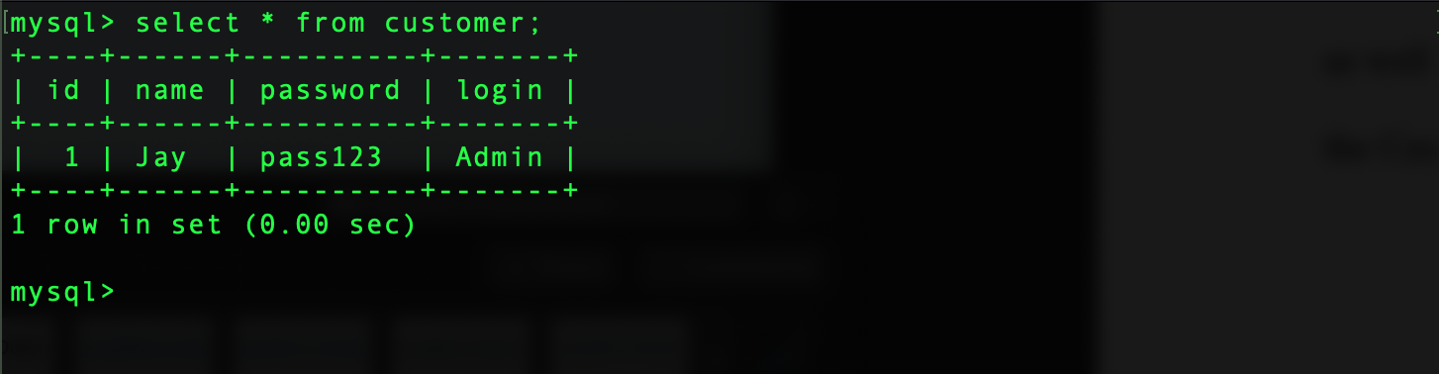

*Create A New Product*

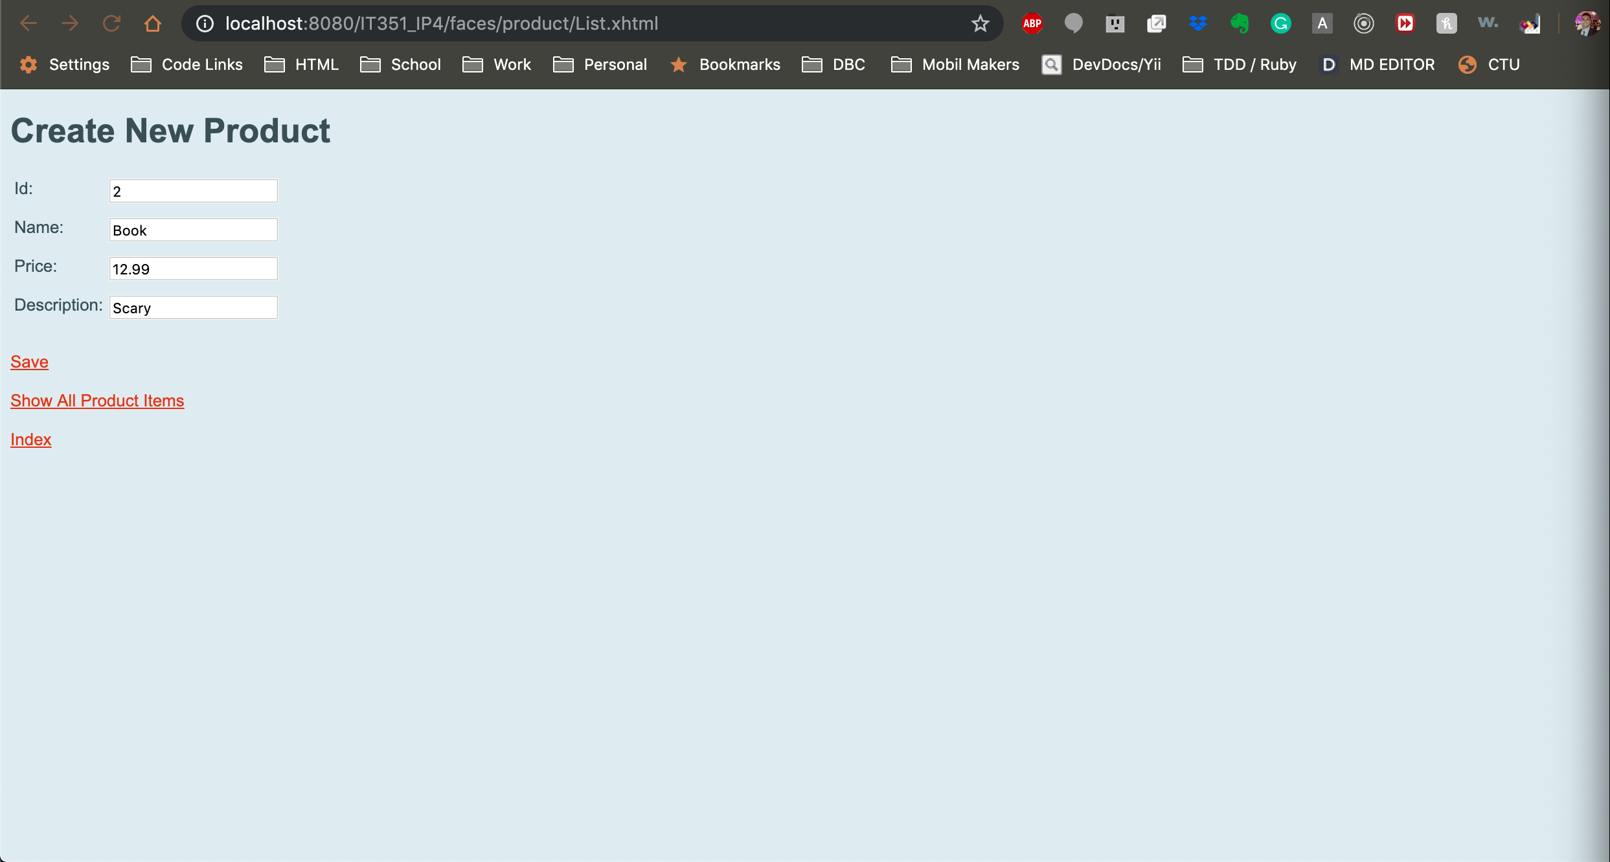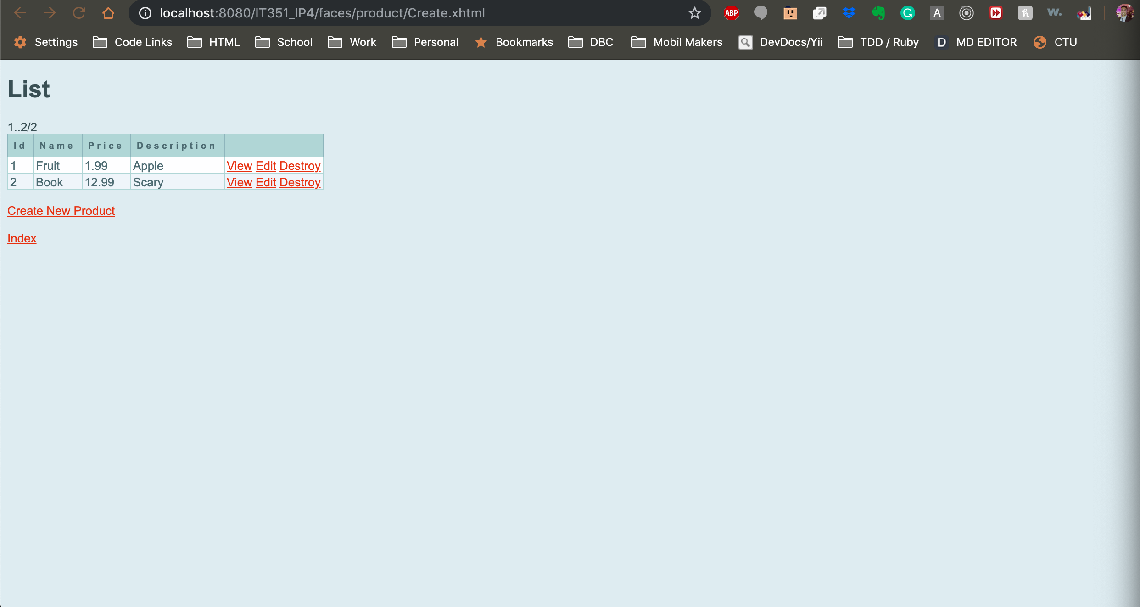

*Update an Existing Product*

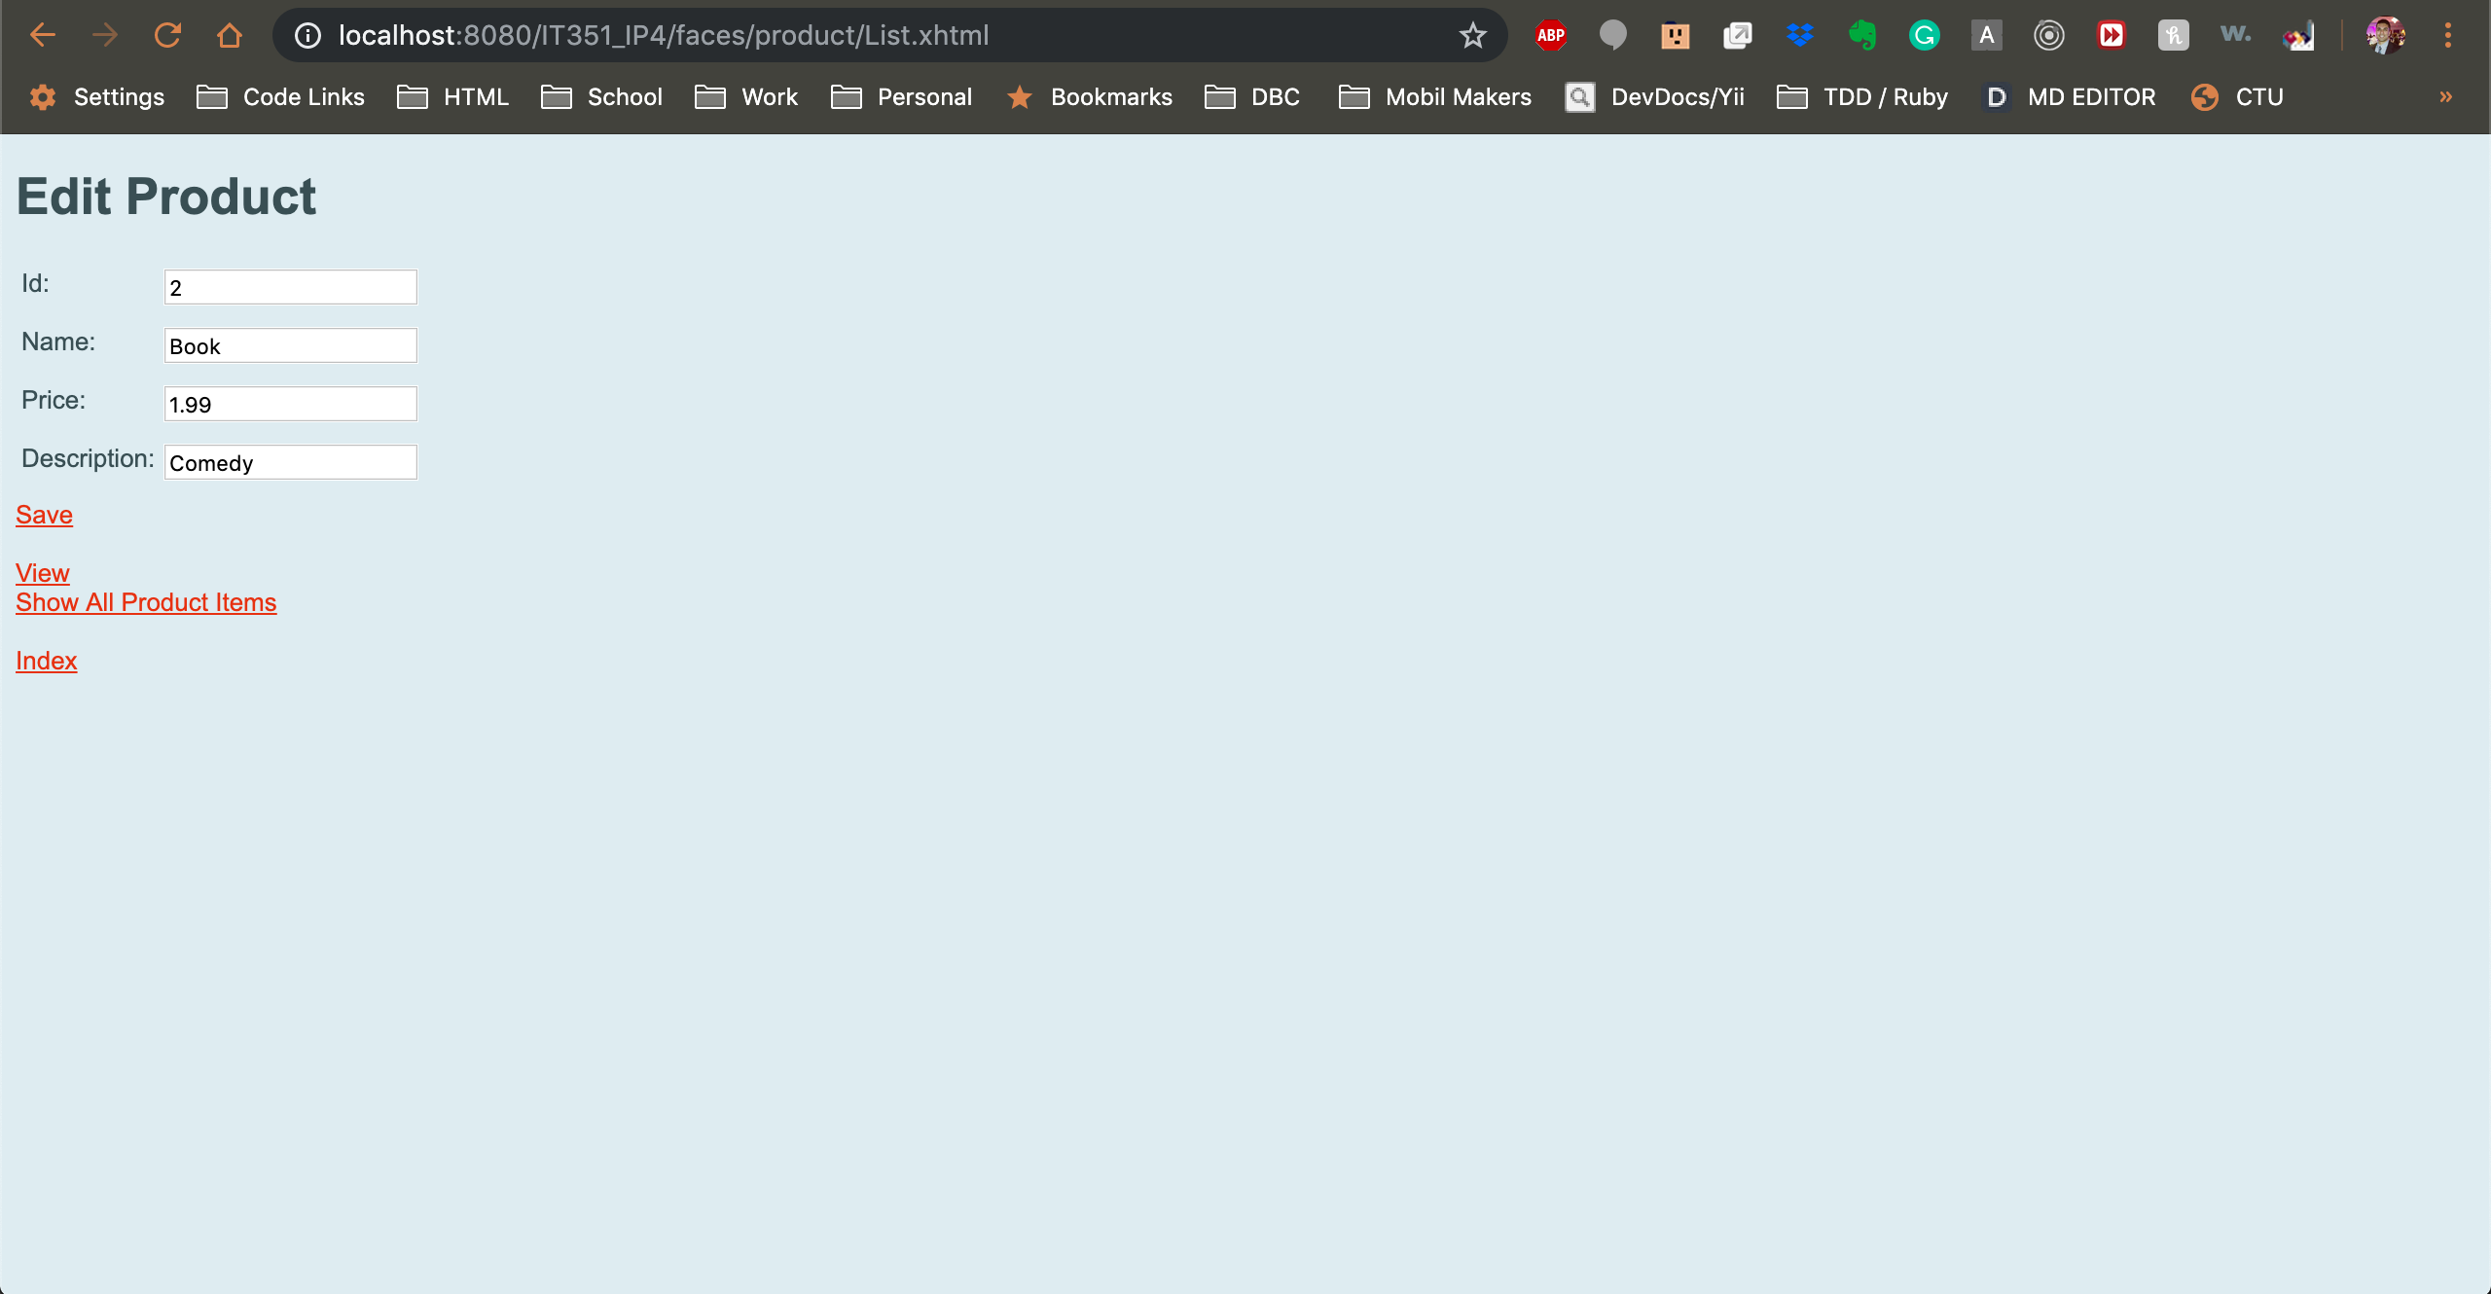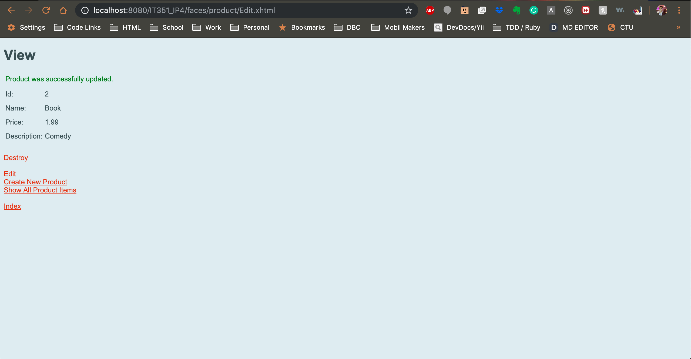

*Read All Existing Products*

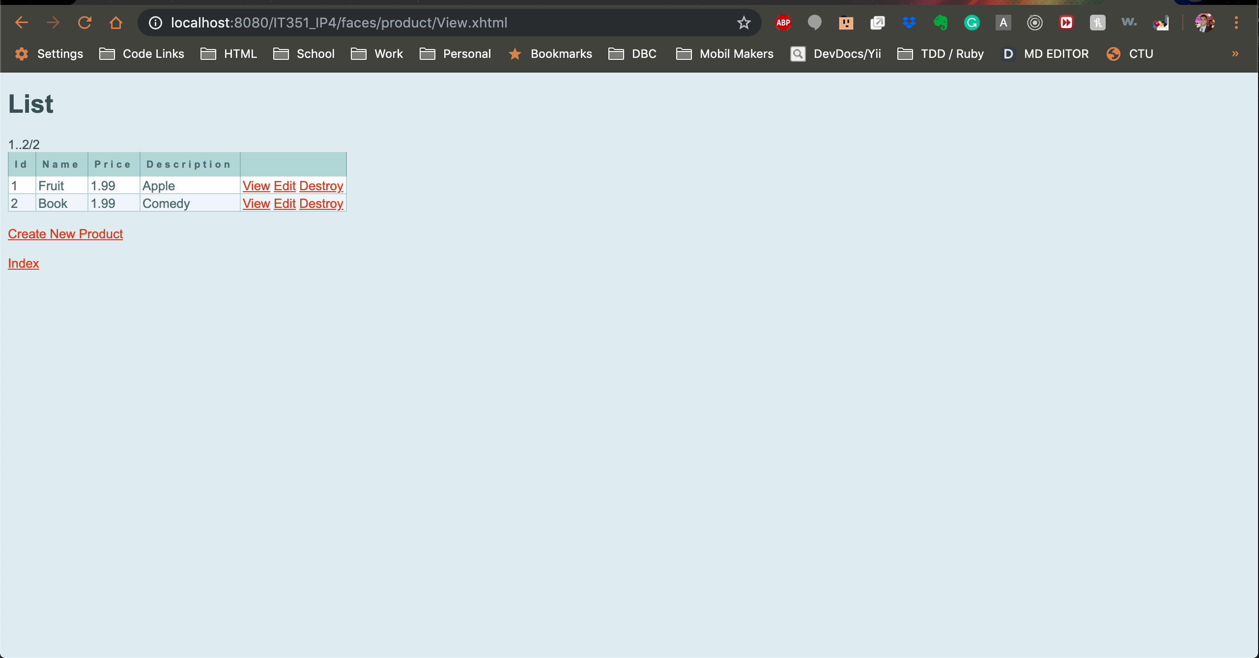

*Destroy an Existing Product*

